DESIGNING OMNI-DIRECTIONAL ANTENNA USING DIRECTIONAL ANTENNAE



**INTERNSHIP REPORT**

**SUBMITTED TO:**

Shri. V. Raj Kumar,

Scientist ’F’,

QRSAM.

**SUBMITTED BY:**

Yathaty Samson Sunny Babu – 21ECB0A67

Preface

In the rapidly evolving field of telecommunications and wireless communication systems, the importance of antennas cannot be overstated. Antennas are the critical components that enable the transmission and reception of electromagnetic waves, forming the backbone of all modern communication networks. The theory behind antennas, their parameters, and their various designs are fundamental knowledge for any engineer or researcher working in this domain.

This report delves into the comprehensive study of antenna theory and its essential parameters, providing a foundational understanding necessary for designing and analyzing various types of antennas. The primary focus is on creating omnidirectional antennas using different configurations, including dipole antennas, horn antennas, microstrip patch antennas, Yagi-Uda antennas, and parabolic reflector antennas.

The report concludes with a summary of the findings and insights gained from studying these various antenna types. It also includes recommendations for future research and potential applications of these antennas in emerging technologies.

By providing a thorough understanding of antenna theory and practical insights into the design and creation of omnidirectional antennas using diverse configurations, this report aims to serve as a valuable resource for students, engineers, and researchers in the field of wireless communication.

Acknowledgement

I, Yathaty Samson Sunny Babu would like to express my profound gratitude to Shri V. Rajkumar, Sc-F, QRSAM for guiding me in the completion of my internship project titled “Designing Omni-Directional Antenna Using Directional Antennae”.

(Shri V.RAJ KUMAR)  
Sc ‘F’  
QRSAM

CONTENTS

Topic Page no

1. Preface………………………………………………………………………
2. Acknowledgement……………………………………………………..
3. Contents……………………………………………………………………
4. Certificate………………………………………………………………….
5. Introduction………………………………………………………………
6. Antenna parameters…………………………………………………..
7. Dipole antenna…………………………………………………………..
8. Horn antenna…………………………………………………………….
9. Microstrip patch antenna……………………………………………
10. Parabolic reflector antenna……………………………………
11. Yagi-uda antenna…………………………………………………..
12. MATLAB codes and Results:
    1. Observing Characteristics of Dipole Antenna Element………………………………………………………………..
    2. Designing Omnidirectional Antenna using Dipole Antenna……………………………..………………………
    3. Observing Characteristics of Horn Antenna Element………………………………………………………………..
    4. Designing Omnidirectional Antenna using Horn Antennae…………………………………………………...
    5. Observing Characteristics of Microstrip Patch Antenna Element………………………………………………….
    6. Designing Omnidirectional Antenna using Microstrip Patch Antennae……………………………………
    7. Observing Characteristics of Parabolic Reflector Antenna Element………………...………………….
    8. Designing Omnidirectional Antenna using Parabolic Reflector Antennae………………..……………….
    9. Observing Characteristics of Yagi-Uda Antenna Element………………...………………………………..
    10. Designing Omnidirectional Antenna using Yagi-Uda Antennae………………………………………………..
13. Conclusion…………………………………………………………….
14. References…………………………………………………………….

2  
3  
4  
5  
6  
9  
17  
23  
29  
37  
44  
  
  
51  
  
54  
  
57  
  
60  
  
63  
  
66  
  
69  
  
72  
  
75  
  
78  
81  
82

CERTIFICATE

This is to mention that the under-mentioned student of B. Tech (ECE) from National Institution of Technology, Warangal has successfully completed the training program on “DESIGNING OMNI-DIRECTIONAL ANTENNA USING DIRECTIONAL ANTENNAE USING MATLAB” at DRDL/Project QRSAM, Dr. APJ ABDUL KALAM MISSILE COMPLEX, Hyderabad. Under my supervision from 24/05/2024 to 08/07/2024 (OFFLINE MODE). The student has completed the entire work successfully as part of Internship training program. During the training period, the conduct of the student was satisfactory.

|  |  |  |  |  |
| --- | --- | --- | --- | --- |
| S.no | Name | Registration No. | Email Address | Phone no. |
| 1. | Yathaty Samson Sunny Babu | 21ECB0A67 | [ys21ecb0a67@student.nitw.ac.in](mailto:ys21ecb0a67@student.nitw.ac.in) | 7305098858 |

(Shri S. JEEVAN BABU)  
Sc ‘F’  
Head, HRD/DHRTM

(Shri V.RAJ KUMAR)  
Sc ‘F’  
QRSAM

Introduction

Antennas are an indispensable part of any wireless communication system. In today’s scenario, although, antenna as a device is not new to common man, but understanding the background concept involved in the working of this device will certainly help in designing new versatile antennas, in order to meet the stringent requirements of wireless communication engineers. 

In any wireless communication system, after a radio frequency (rf) signal has been generated in a transmitter, some means must be used to radiate this signal through space to a receiver. The device that does this job is the antenna. The transmitter signal energy is sent into space by a transmitting antenna, the rf signal is then picked up from space by a receiving antenna.

The rf energy is transmitted into space in the form of an electromagnetic field. As the travelling electromagnetic field arrives at the receiving antenna, a voltage is induced into the antenna (usually a conductor). The rf voltages induced into the receiving antenna are then passed into the receiver and converted back into the transmitted rf information.

So, antennas can be thought of as a “transducer” that converts radio waves into electrical currents and voltages and vice versa. More specifically, these are devices designed to radiate or receive electromagnetic energy efficiently in a prescribed manner.

Types of Antennas:

1. Wire antennas: (Fig. 1, 2 and Fig. 9 single element)
   1. dipole, monopole, loop antenna, helix.
   2. Usually used in personal applications, automobiles, buildings, ships, aircrafts and spacecrafts.
2. Aperture antennas: (Fig. 3, 4)
   1. horn antennas, waveguide opening.
   2. Usually used in aircrafts and space crafts, because these antennas can be flushmounted.
3. Reflector antennas: (Fig. 5)
   1. Parabolic reflectors, corner reflectors
   2. These are high gain antennas usually used in radio astronomy, microwave communication and satellite tracking
4. Lens antennas:
   1. Convex-plane, convex-convex, convex-concave and concave-plane lenses
   2. These antennas are usually used for very high frequency applications
5. Microstrip antennas: (Fig. 6)
   1. Rectangular, circular etc. shaped metallic patch above a ground plane
   2. Used in aircraft, spacecraft, satellites, missiles, cars, phones etc.
6. Array antennas: (Fig. 7, 8, and 9)
   1. Yagi-Uda antenna, microstrip patch array, aperture array, slotted waveguide array.
   2. Used for very high gain applications with added advantage, such as, controllable radiation pattern.

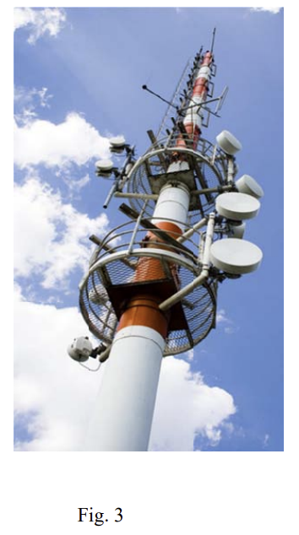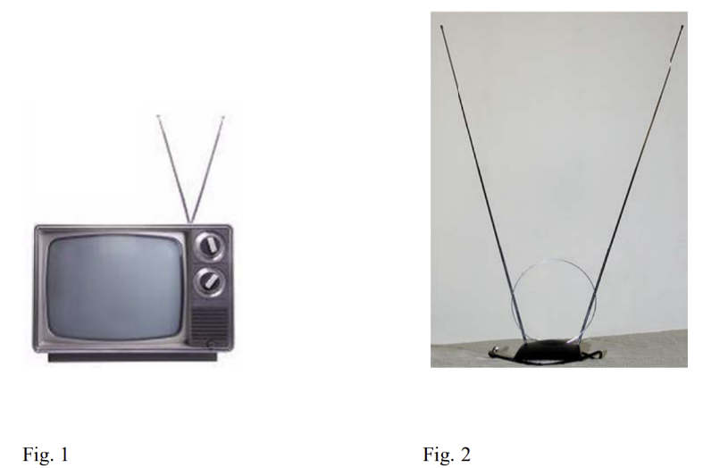

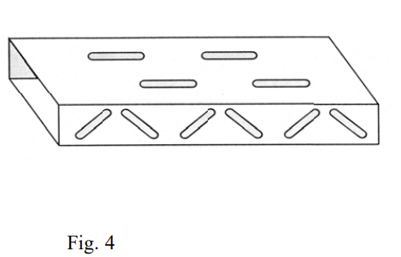

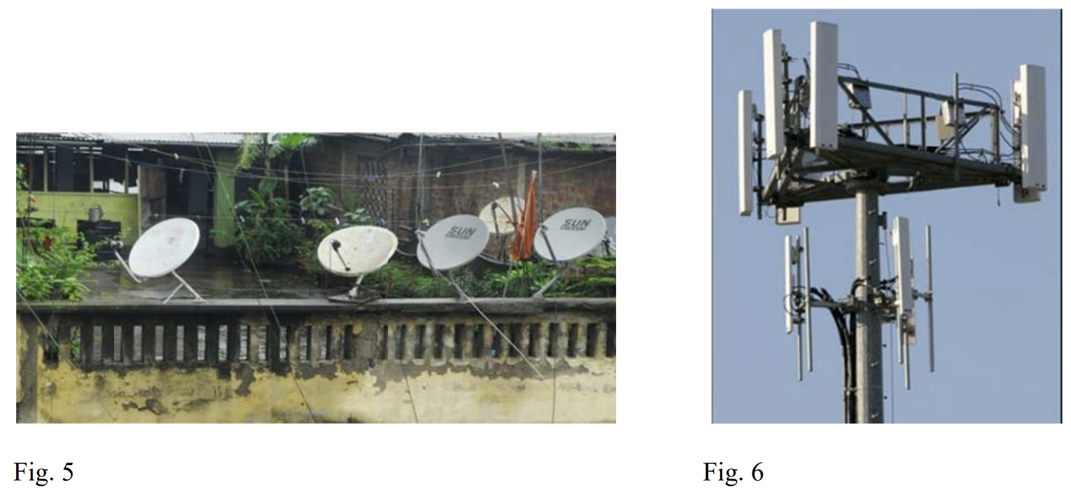

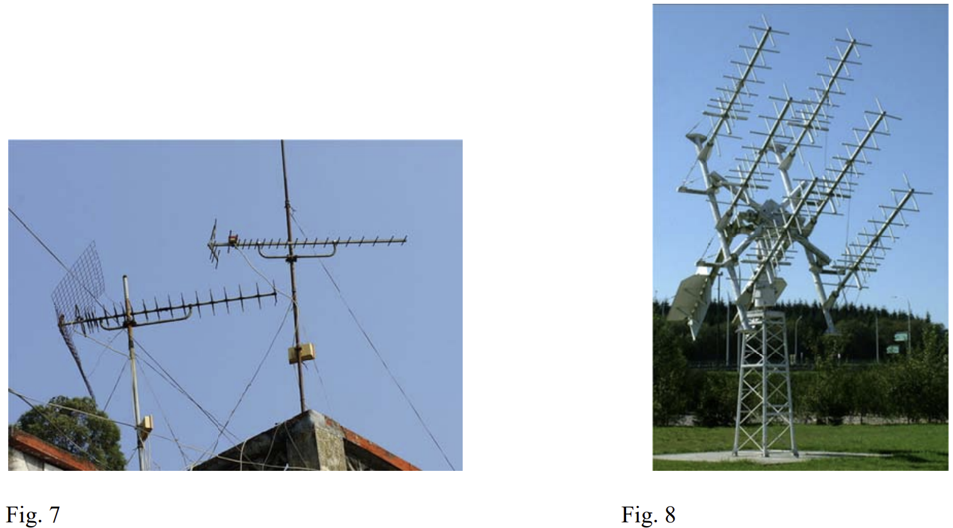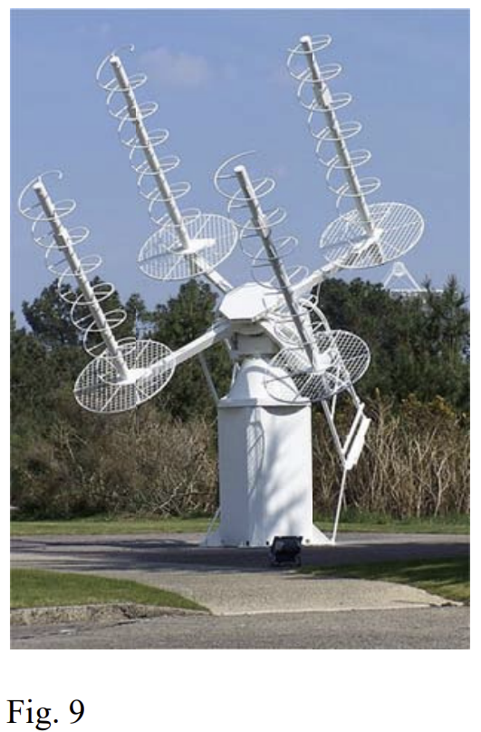

Antenna Parameters:

1. **Poynting Vector:**  
                               The magnitude of the Poynting vector gives the instantaneous or average power density of the electromagnetic wave. Its direction gives the direction of the power flow at that particular point.
2. 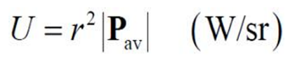**Power Intensity:**  
    It is the power radiated in a given direction per unit solid angle and has units of Watts per steradian (W/sr).  
    **Note**: U is a function of direction (Theta, phi) only and not distance (r).
3. **Radiated Power:**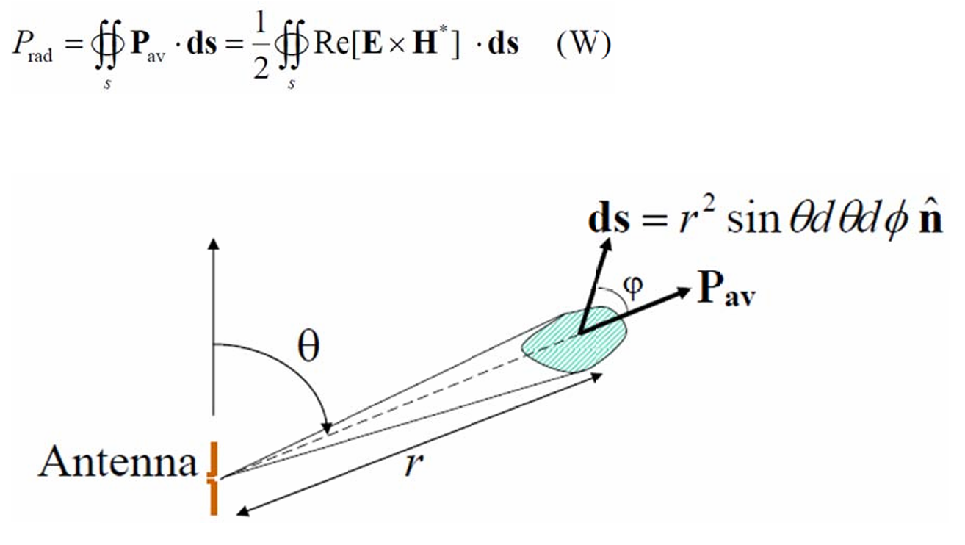
4. **Radiation Pattern:**  
    Radiation pattern is a graphical representation of the radiation properties of the antenna as a function of space coordinates.  
   The characteristics that can be noted down from a typical antenna radiation pattern are:  
    ->Major lobe   
    ->Minor lobe   
    ->Half power beamwidth (HPBW)   
    ->Beamwidth between first nulls (BWFN)  
   **NOTE:** By the reciprocity therapy the radiation Pattern Of an antenna in the transmitting mode is same as those for the antenna in the receiving mode.  
   There are two types of radiation patterns one is isotropic and the other is omnidirectional radiation pattern.
5. **Field regions:**  
    Field region is generally defined as the space surrounding an antenna which is usually divided into two regions a near field region and a far field region.  
    Farfield region is defined as the region of the field of an antenna where the rectangular field distribution is independent of the distance from the antenna. This region is also called as **Fraunhofer Region**  
    The field immediately surrounding the antenna and the far field region is known as the Nearfield region this region is again divided into two sub regions: **reactive near field** and **radiating near field**.  
     
     
     
   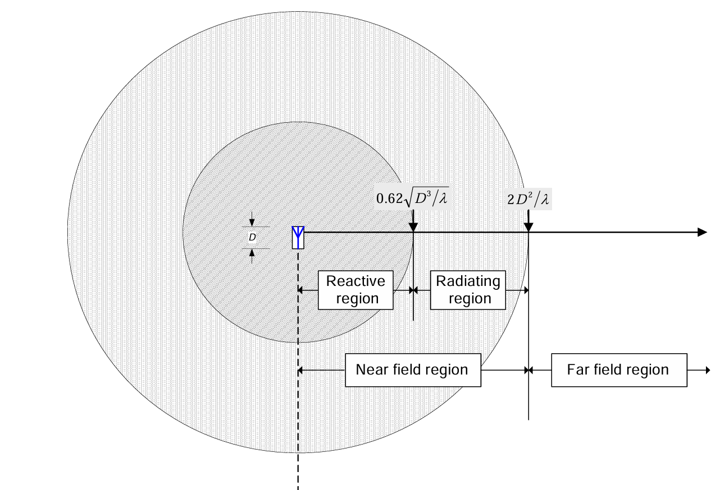
6. **Directivity:** The directivity D of an antenna is the ratio of the radiation intensity U in the given direction (Theta, Phi) to the radiation intensity averaged over all directions Uo.  
   This parameter indicates how well an antenna concentrates power into a limited solid angle.  
   **NOTE:** The directivity of an isotropic source is 1, whereas it is more 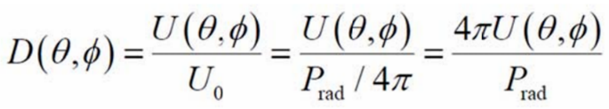than 1 for any other antenna.
7. 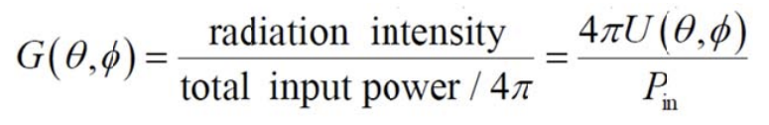**Gain:**  
    The gain or power gain of an antenna in a certain direction (θ, φ) is defined as:  
   where Pin is the output power to the antenna and is related to the radiated power Prad as:  
   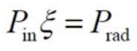  
   In the above equation, ξ is the efficiency of the antenna. It accounts for the various lossess such as refraction loss, dielectric loss, conduction loss, and polarization mismatch loss.  
    Taking the efficiency into account, the gain and the directiboty are related by:  
   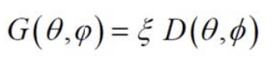
8. **Antenna polarization:**  
    The polarization of an antenna in a given direction is defined as the polarization of the plane wave transmitted by the antenna in that direction. The polarization of a wave transmitted (or received by an antenna is the locus of the tip of the instantaneous electric field vector E traces out with time at a fixed observation point.

If the locus is a straight line 🡺 Linear polarization  
 If the locus is a circle 🡺 Circular polarization  
 if the locus is al ellipse 🡺 Elliptical polarisatio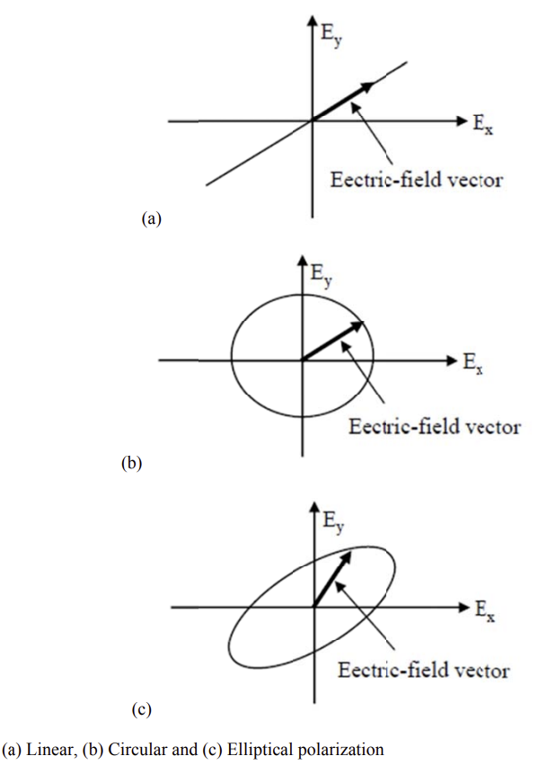n

1. **Axial ratio:**  
    The polarization state of an EM wave can also be indicated by the axial ratio (AR). It is defined as  
   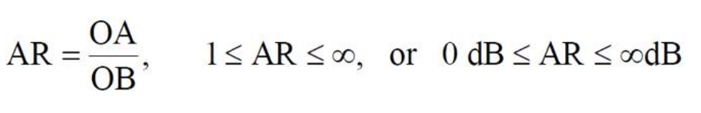  
   Where OA and OB are the major axes of the polarisation ellipse respectively.  
   Very often, we use the AR bandwidth and the AR beamwidth to characterize the polarization of an antenna. The AR bandwidth is the frequency bandwidth in which the AR of an antenna changes less than 3-dB from its minimum value. The AR beamwidth is the angle span over which the AR of an antenna changes less than 3-dB from its 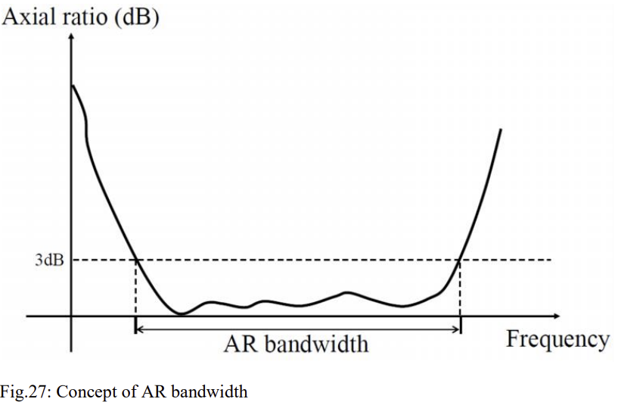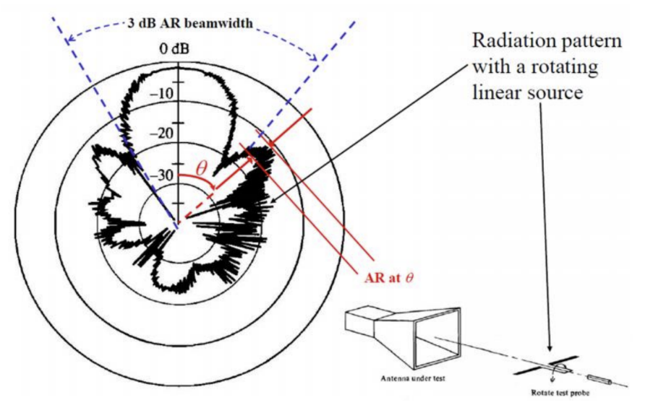minimum value.   
   



1. **Input Impedance:** The input impedance Za of a transmitting antenna is the ratio of the voltage to current at the terminals of the antenna.  
     
    Za=Ra+jXa Ra: Input resistance, Xa: input reactance  
    Ra=Rr+Rl Rr: Radiation resistance, Rl: Loss resistance  
   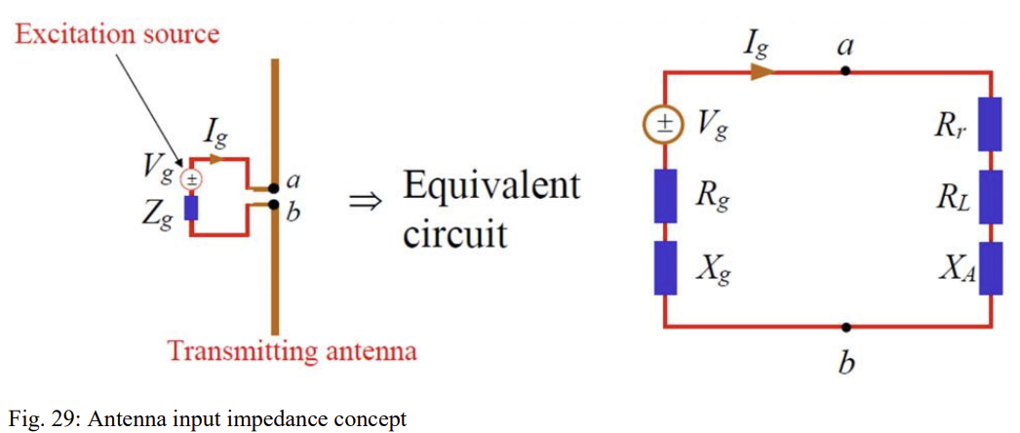  
   If we know the input impedance of a transmitting antenna, the antenna can be viewed as an equivalent circuit, as shown in the above Figure.  
    Zg=Rg+jXg  
   Zg: internal impedance of the excitation source   
   Rg: internal impedance of the excitation source   
   Xg: internal reactance of the excitation source   
   Ig: antenna terminal current



1. 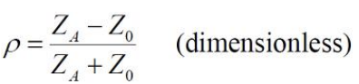**Reflection Coefficient:** The reflection coefficient of a transmitting antenna is defined by:
   1. Reflection coefficient can be calculated or measured.
   2. The magnitude of reflection coefficient is from 0 to 1.
   3. When the transmitting antenna is not match, that is, ZA ≠ Z0, there is a loss due to reflection (return loss) of the wave at the antenna terminals. When expressed in dB, ρ is always a negative number.
   4. Sometimes we use S11 to represent ρ.
2. 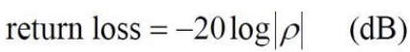**Return Loss:**The return loss of a transmitting antenna is defined as:  
   The possible values of return loss are from 0 dB to ∞ dB. Return loss is always a positive number.
3. **VWSR:**  
    Same as ρ and the return loss, the **Voltage Standing Wave Ratio** (VSWR) is also a common parameter used to characterize the matching property of a transmitting antenna. The VSWR of a transmitting antenna is defined as:  
   Possible values of VSWR are from 1 to ∞.   
   VSWR = 1 ⇒ perfectly matched, VSWR = ∞ ⇒ completely unmatched
4. 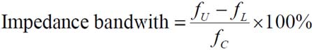**Impedance Bandwidth:** Impedance bandwidth is defined as

The symbols in the above equation are depicted in Figure below.

Concept of impedance bandwidth

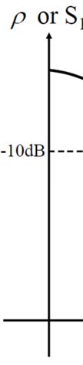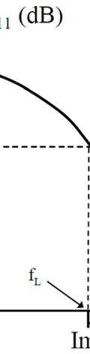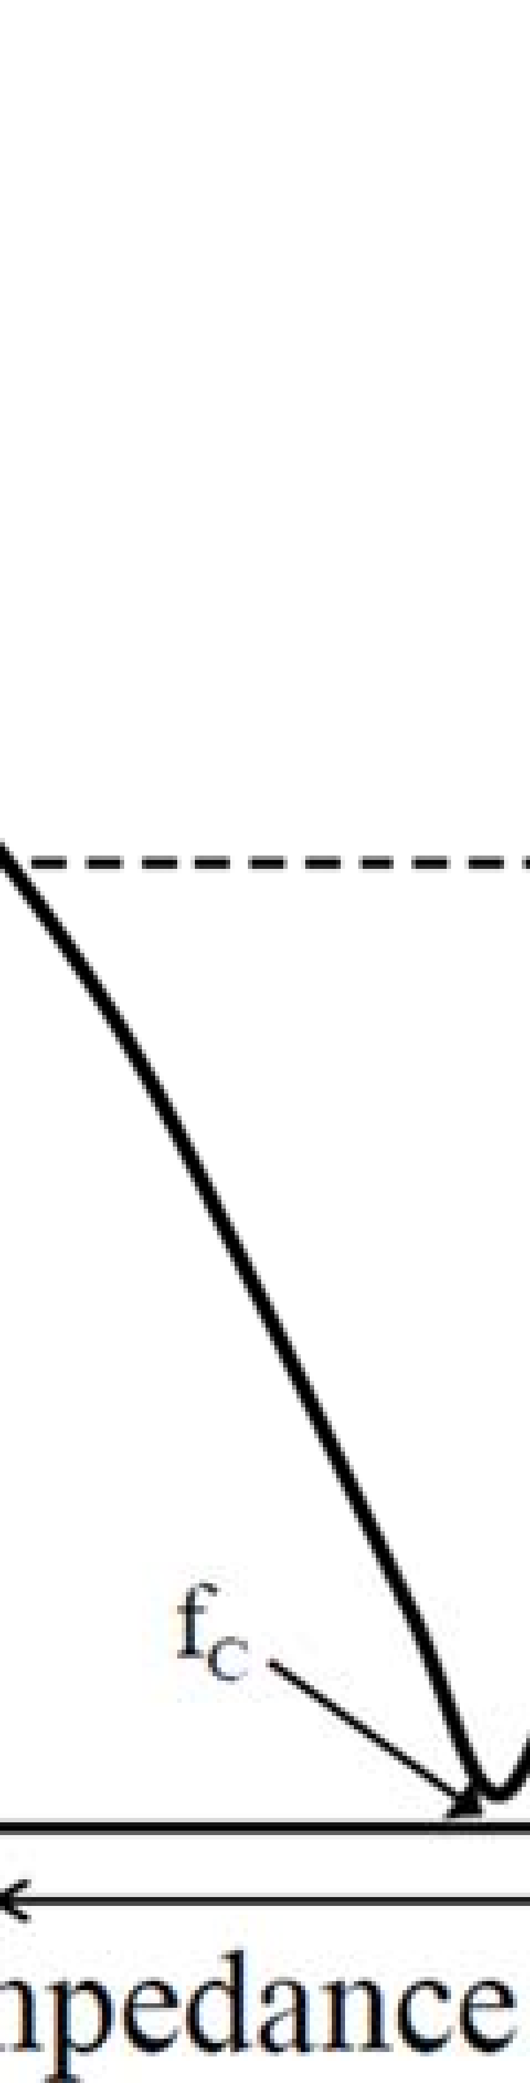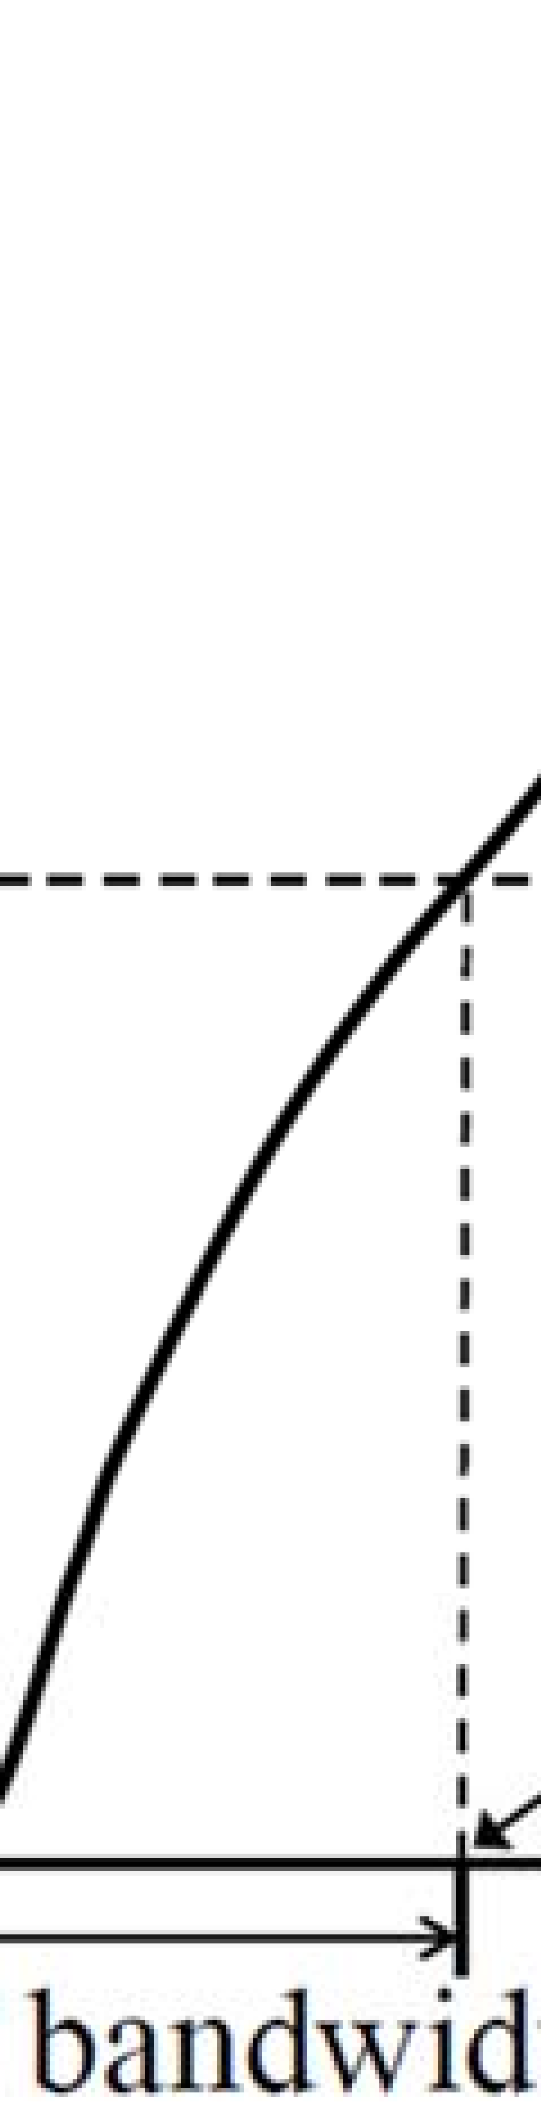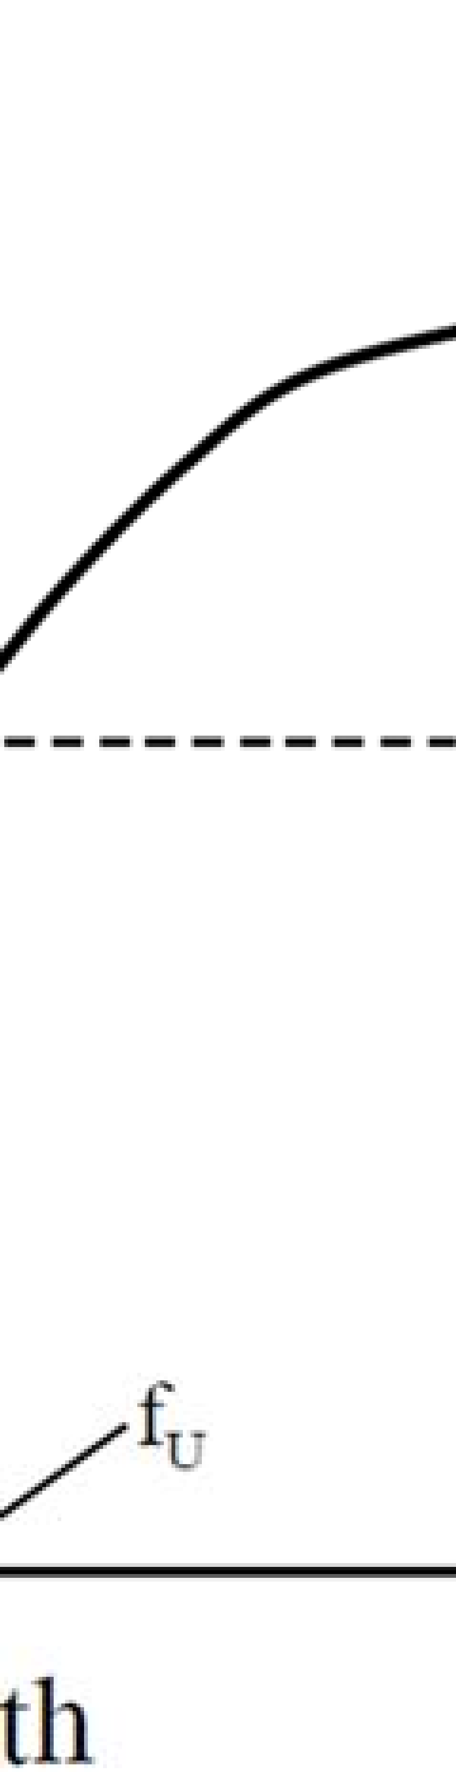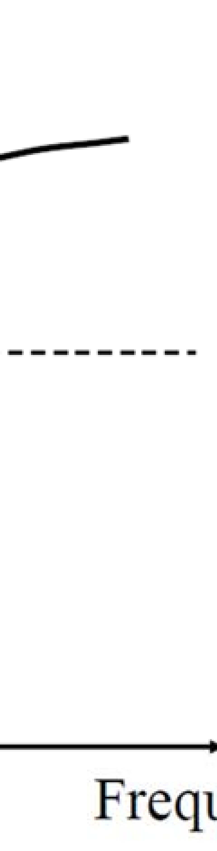

**NOTE:** When  = -10 dB,

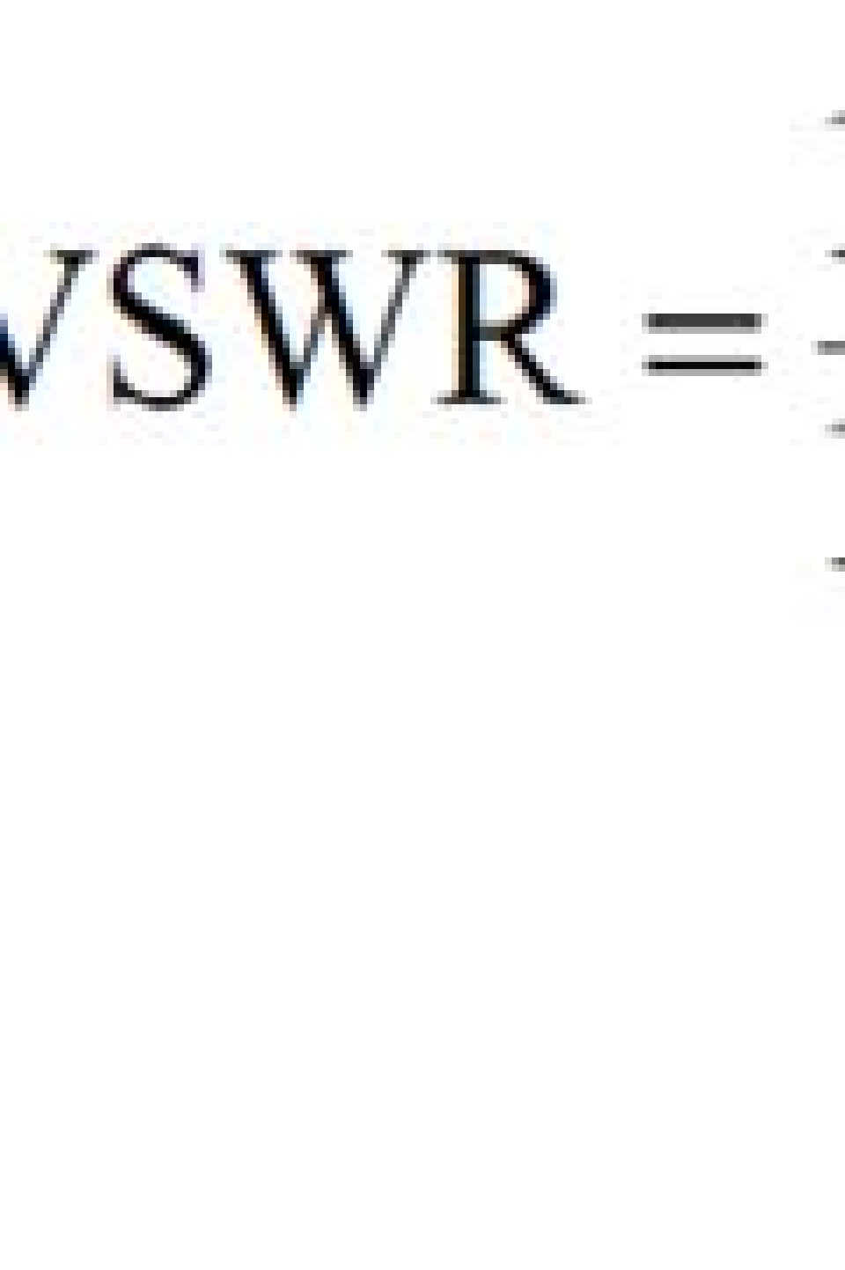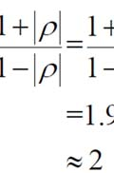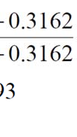

Hence the impedence bandwidth can also be specified by the frequency range within which VSWR  2.

1. **Effective aperture:**  
    It is a measure of the ability of an antenna to collect power from an incident wave and deliver it to its terminals.

The effective aperture (area) of a receiving antenna looking from a certain direction (, ) is the ratio of the average power *P*L delivered to a matched load to the magnitude of the average power density *P*avi of the incident electromagnetic wave at the position of the antenna multiplied by the normalized power pattern *P*av (, ) of that antenna.

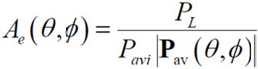

The effective aperture is related to the directivity as:

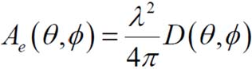

A maximum effective area *A*em can be defined when the antenna is receiving in its maximum-directivity direction. That is,

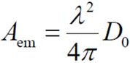

DIPOLE ANTENNA

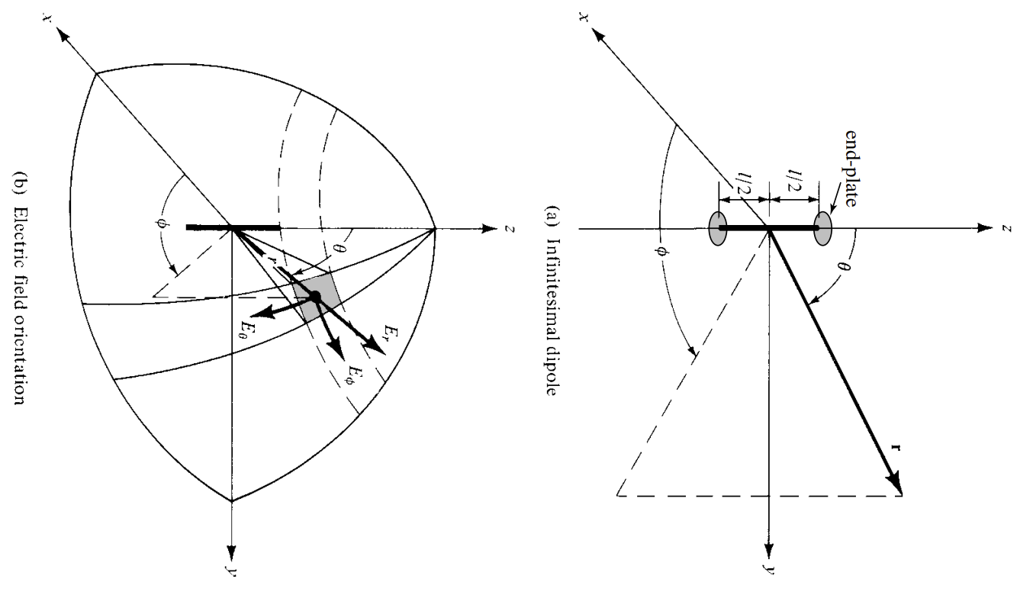A dipole antenna is one of the simplest and most widely used types of antennas. It consists of two conductive elements, usually metal rods, that are aligned end-to-end and separated by a small gap where the feed line is connected.

Basic **Structure** of a Dipole Antenna

1. **Conductive Elements:**
   * The dipole antenna consists of two conductive elements (typically metal rods or wires) aligned in a straight line, end-to-end.
   * These elements are usually of equal length.
2. **Length of Elements:**
   * The total length of the dipole antenna is generally designed to be half the wavelength (λ/2) of the operating frequency.
   * Each element is therefore (λ/4) long.
3. **Feed Point:**
   * The feed point is located at the center of the antenna, where the two conductive elements are separated by a small gap.
   * This is where the transmission line or feed line (such as coaxial cable) connects to the antenna.
4. **Balun (Optional):**
   * A balun (balanced-to-unbalanced transformer) is often used at the feed point to transition between the balanced antenna and the unbalanced feed line.
   * This helps to prevent feed line radiation and ensures better performance.
5. **Mounting:**
   * The dipole antenna can be mounted horizontally, vertically, or at an angle, depending on the desired polarization and application.
   * Horizontal mounting is common for many applications, providing horizontal polarization.
6. **Insulators:**
   * Insulators may be used at the ends of the conductive elements to isolate them from mounting structures or other objects.

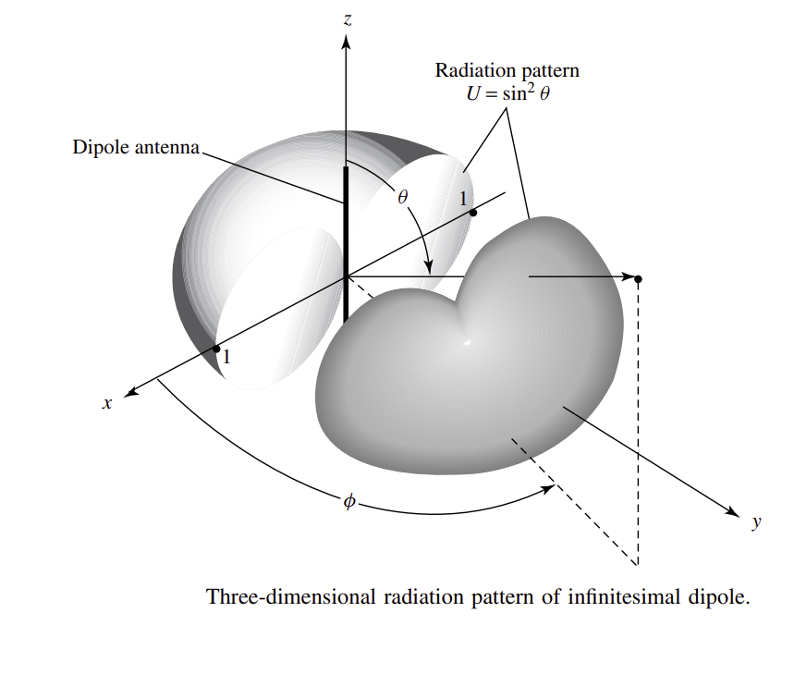

A dipole antenna has several key **properties** that define its performance and applications. Here are the main properties of a dipole antenna:

1. **Length:**
   * Typically half the wavelength (λ/2) of the frequency it is designed to operate at.
   * Can be shortened or lengthened, but this affects its impedance and radiation pattern.
2. **Impedance:**
   * Resonant impedance is approximately 73 ohms for a half-wave dipole in free space.
   * Impedance varies with frequency and the antenna's environment.
3. **Radiation Pattern:**
   * Doughnut-shaped, with maximum radiation perpendicular to the axis of the elements.
   * Nulls along the axis of the elements.
4. **Bandwidth:**
   * Limited bandwidth, typically a few percent of the center frequency.
   * Bandwidth can be increased with design modifications (e.g., thickening the elements, using a folded dipole).
5. **Polarization:**
   * Linearly polarized.
   * The polarization direction is parallel to the axis of the elements.
6. **Gain:**
   * Gain is around 2.15 dBi for a half-wave dipole.
   * Gain can be affected by the height above ground and surrounding environment.
7. **Efficiency:**
   * Generally high efficiency, close to 100% in ideal conditions.
   * Efficiency decreases if there are losses in the materials or feed system.
8. **Resonant Frequency:**
   * Resonant frequency is determined by the length of the elements.
   * Can be adjusted by changing the length or using loading techniques.
9. **Radiation Resistance:**
   * Radiation resistance of a half-wave dipole is around 73 ohms.
   * Total input resistance includes radiation resistance and any loss resistance.
10. **Directional Properties:**
    * Bi-directional in the plane perpendicular to the axis of the elements.
    * Unidirectional radiation can be achieved by using reflectors or directors.

These properties make the dipole antenna a versatile and widely used antenna type in various RF applications.

**Applications**:

* Dipole antennas are widely used in various applications, including radio and television broadcasting, wireless communications, and as elements in more complex antenna arrays.
* They are often used because of their simplicity, ease of construction, and efficient performance.

**Creating an omnidirectional antenna using multiple dipole antennas** involves arranging the dipoles in a specific configuration that allows them to radiate uniformly in all horizontal directions. One common method to achieve omnidirectional radiation is by arranging multiple dipole antennas in a circular array. Here’s how you can do it:

1. **Number of Dipoles:**
   * For simplicity, let’s use four dipoles for this example. This will provide a good balance between simplicity and omnidirectional coverage.
2. **Spacing Calculation:**
   * Let’s assume the operating frequency is *f*, and the wavelength is λ=*c/f* ​, where *c* is the speed of light.
   * For a frequency of 300 MHz, λ=1 meter. Spacing the dipoles at λ/2 would mean 0.5 meters apart.
3. **Positioning the Dipoles:**
   * Arrange the four dipoles in a circular manner. Each dipole is positioned at a 90° angle from its neighbour, forming a square when viewed from above.
4. **Feed Network:**
   * Design a feed network that splits the input signal into four equal parts, each with the same amplitude and phase.
   * A simple way is to use a four-way power divider. Ensure that the length of the cables from the power divider to each dipole is equal to maintain phase coherence.
5. **Mounting:**
   * Mount each dipole vertically on a supporting structure, ensuring that the height above ground is the same for each dipole.
   * Use insulating materials to prevent electrical contact between the dipoles and the support structure.

HORN ANTENNA

A horn antenna is a type of antenna that consists of a flaring metal waveguide shaped like a horn to direct radio waves in a beam. It is used primarily in the microwave frequency range and serves to transition the waves from a waveguide into free space with minimal loss. The horn shape helps to gradually match the impedance of the waveguide to that of free space, reducing reflections and allowing efficient radiation. Horn antennas are widely used in applications such as radar systems, satellite communications, and as feed antennas for parabolic reflectors due to their simple design, wide bandwidth, and good directional properties.

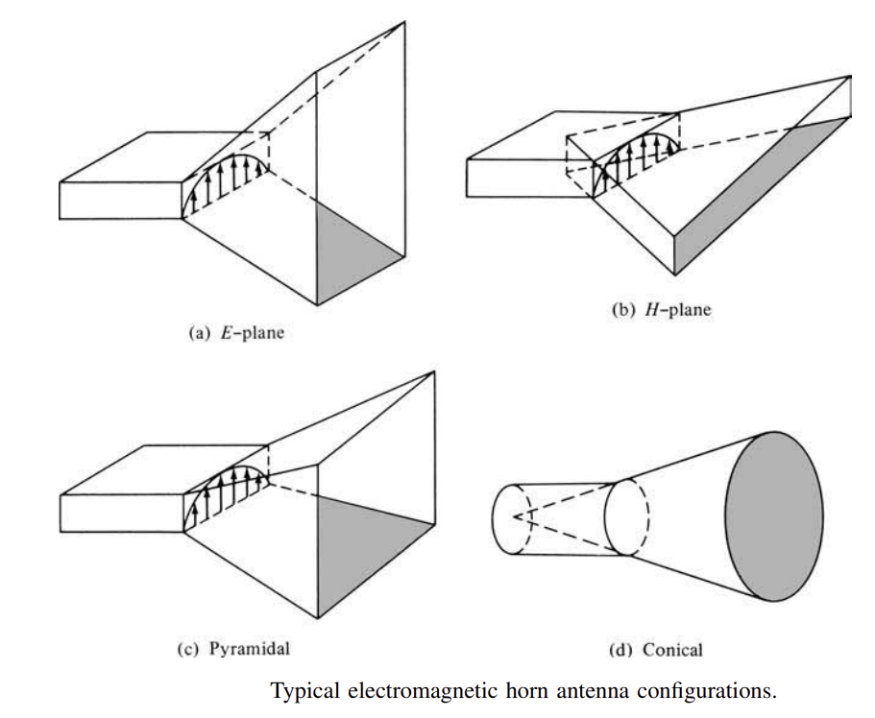

Basic **structure** of a horn antenna:

1. **Waveguide**: A metallic tube that guides the electromagnetic waves to the horn. The waveguide ensures that the waves are properly directed into the horn.
2. **Flare or Horn**: The flared portion of the antenna, which can be conical, pyramidal, or sectoral in shape. The flare gradually increases in size to match the impedance of the waveguide to that of free space, minimizing reflections and losses.
3. **Aperture**: The open end of the horn where the electromagnetic waves are radiated into free space. The size and shape of the aperture determine the radiation pattern and beamwidth of the antenna.
4. **Feed Point**: The location where the waveguide is connected to the horn, often involving a transition section that helps in efficient transfer of energy from the waveguide to the horn.

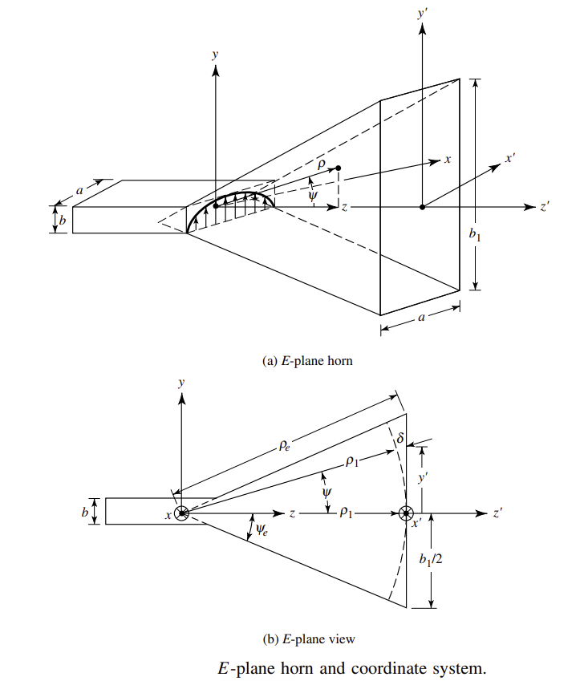This simple yet effective design allows horn antennas to achieve high directivity, low standing wave ratio (SWR), and wide bandwidth, making them suitable for various high-frequency applications.

Horn antennas possess several key **properties** that make them useful for various applications:

1. **High Directivity**: Horn antennas can produce narrow, focused beams, allowing them to effectively transmit or receive signals in specific directions. This high directivity enhances their ability to detect weak signals from a particular direction while reducing interference from other directions.
2. **Wide Bandwidth**: Horn antennas can operate over a wide range of frequencies, making them versatile for different applications. Their design allows for efficient radiation of electromagnetic waves across a broad spectrum.
3. **Low Standing Wave Ratio (SWR)**: The gradual transition from the waveguide to free space in a horn antenna minimizes reflections, resulting in a low SWR. This indicates efficient power transfer and reduced signal losses.
4. **Simple Construction**: The design of horn antennas is relatively straightforward, involving a flared waveguide. This simplicity makes them easy to manufacture and maintain.
5. **Impedance Matching**: The flared structure of the horn helps in gradually matching the impedance of the waveguide to that of free space, which reduces reflection and power loss, improving the overall efficiency of the antenna.
6. **Polarization Control**: Horn antennas can be designed to produce specific polarizations (e.g., linear, circular), which can be important for certain applications where signal orientation matters.
7. **Stable Radiation Pattern**: The radiation pattern of a horn antenna is typically stable and predictable, making it suitable for applications requiring precise control over the direction and shape of the emitted beam.

These properties make horn antennas ideal for applications such as radar systems, satellite communications, microwave link systems, and as feed horns for parabolic reflectors.

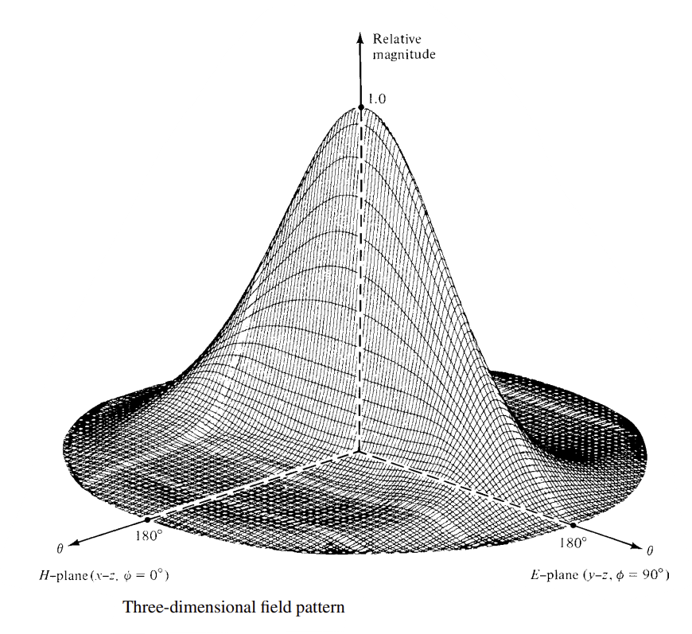

**Applications**:

1. **Radar Systems**: Horn antennas are used in radar systems for both transmitting and receiving signals. Their high directivity allows for accurate detection and tracking of objects.
2. **Satellite Communications**: In satellite communication systems, horn antennas are used to transmit and receive signals between ground stations and satellites. Their wide bandwidth and low SWR make them ideal for this purpose.
3. **Microwave Communication Links**: Horn antennas are employed in point-to-point microwave communication links, where they help in establishing reliable high-frequency connections over long distances.
4. **Antenna Measurement**: Horn antennas are used as reference antennas in antenna measurement setups due to their well-defined radiation patterns and stable performance.
5. **Radio Astronomy**: In radio telescopes, horn antennas are used to collect and focus radio waves from celestial sources. Their high directivity helps in accurately pinpointing and studying distant astronomical objects.

**Creating an omnidirectional antenna using horn antennas** involves a specific design approach to ensure the antenna radiates equally in all directions. Here are the steps to create such an antenna:

1. **Select Horn Antenna Type**: Choose a horn antenna design that supports omnidirectional radiation characteristics. One common type is the conical horn antenna, which can be optimized for omnidirectional performance.
2. **Design the Horn**: Calculate the dimensions of the horn antenna to achieve the desired operating frequency and radiation pattern. For omnidirectional antennas, the flare angle and aperture size are critical factors.
3. **Feed Design**: Determine the feeding mechanism for the horn antenna. This could involve a coaxial feed, waveguide feed, or other suitable methods depending on the antenna design and frequency range.
4. **Radiation Pattern Optimization**: Modify the horn antenna design to achieve a more omnidirectional radiation pattern. This may involve adjustments to the flare angle, length, or aperture shape to minimize sidelobes and ensure uniform radiation in all directions.
5. **Testing and Simulation**: Use simulation software or perform practical tests to verify the radiation pattern and impedance matching of the omnidirectional horn antenna design. Adjust the design as necessary based on simulation results or measurements.
6. **Fabrication**: Fabricate the horn antenna using appropriate materials and manufacturing techniques. Ensure precision in dimensions and alignment to maintain the desired radiation characteristics.
7. **Mounting and Integration**: Mount the horn antenna in a suitable housing or support structure to ensure stability and protection from environmental factors. Consider the antenna's placement and surroundings to minimize interference and maximize performance.
8. **Performance Evaluation**: Conduct thorough performance testing of the omnidirectional horn antenna in real-world conditions. Measure its gain, radiation pattern, SWR, and other relevant parameters to ensure it meets the desired specifications.
9. **Optimization and Fine-Tuning**: Fine-tune the antenna design if necessary to improve its performance or address any issues identified during testing. This may involve minor adjustments to the dimensions, feed mechanism, or materials used.

By following these steps, you can design and create an omnidirectional antenna using horn antennas tailored to specific frequency bands and application requirements.

MICROSTRIP PATCH ANTENNA

A microstrip patch antenna is a type of antenna that operates at microwave frequencies, typically in the GHz range. It consists of a radiating patch on one side of a dielectric substrate with a ground plane on the other side. The patch can be rectangular, circular, or another shape, and it is typically fed by a coaxial cable or a microstrip line. Microstrip patch antennas are compact, lightweight, and relatively easy to fabricate using printed circuit board (PCB) technology, making them widely used in various wireless communication applications such as satellite communication, radar systems, and WLAN (Wireless Local Area Network) devices.

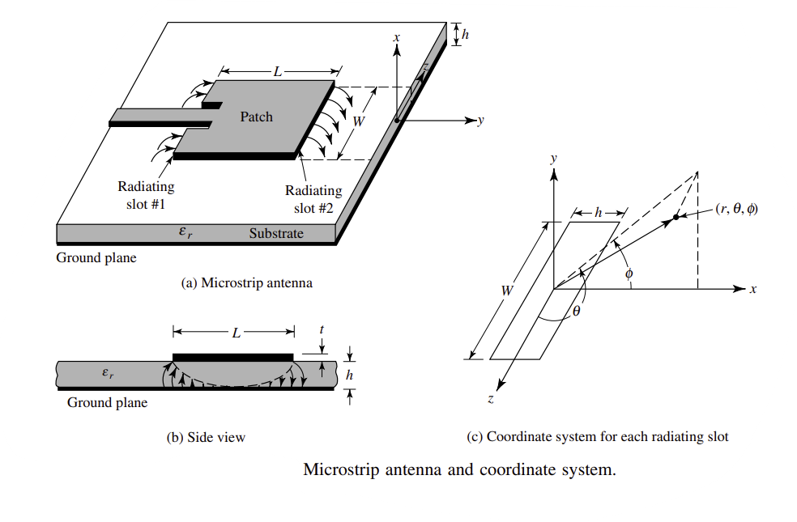

The **structure** of a microstrip patch antenna typically consists of the following components:

1. **Radiating Patch**: This is the main radiating element of the antenna and is usually made of conductive material such as copper. It can be square, rectangular, circular, or another shape depending on the design requirements. The patch is placed on the top surface of a dielectric substrate.
2. **Dielectric Substrate**: Beneath the radiating patch is a dielectric substrate, which provides mechanical support to the patch and helps determine the electrical characteristics of the antenna. Common substrate materials include fiberglass epoxy (FR4), ceramic, or other low-loss materials with a relative permittivity (dielectric constant) ranging typically from 2 to 12.
3. **Ground Plane**: Below the substrate is a conducting ground plane that acts as a reflector for the electromagnetic waves. It improves the antenna's performance by enhancing radiation efficiency and providing a reference point for the electromagnetic fields.
4. **Feedline**: The patch antenna is usually fed by a microstrip transmission line, which is a narrow strip of conductor that connects the patch to the feed point (where the coaxial cable or other feed mechanism is connected). The feedline can be designed to match the impedance of the patch antenna to the feeding source (often 50 ohms for coaxial cables).
5. **Additional Layers (Optional)**: In some designs, additional layers such as a cover layer or protective coating may be added above the radiating patch for mechanical protection or environmental durability.

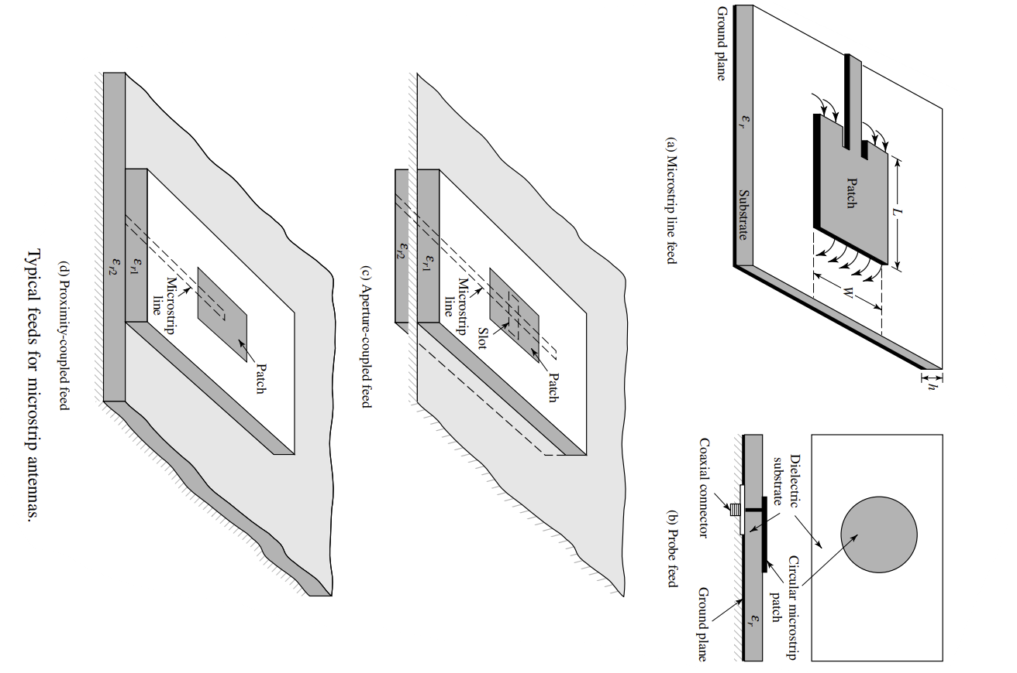The dimensions and shapes of these components (especially the patch and substrate) are critical in determining the operating frequency, bandwidth, radiation pattern, and other performance characteristics of the microstrip patch antenna. Design parameters such as the patch size, substrate thickness, dielectric constant, and feed location are carefully chosen to optimize antenna performance for specific applications.

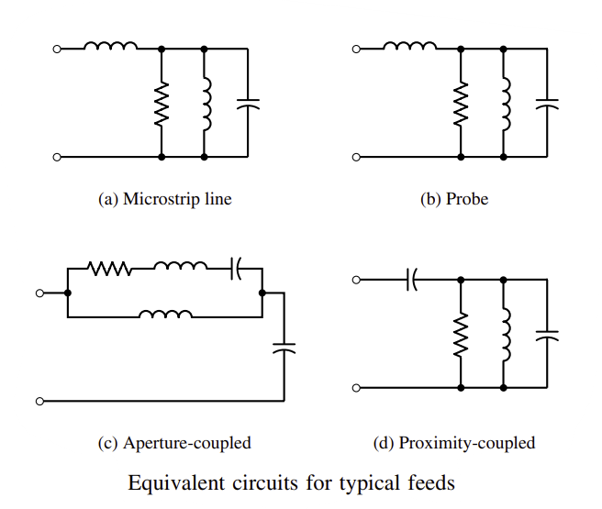

Microstrip patch antennas possess several key **properties** that make them advantageous for various applications:

1. **Compact Size**: Microstrip patch antennas are physically small and flat, making them suitable for integration into compact devices and systems where space is limited. Their low profile and planar structure make them easy to mount on surfaces or within electronic devices.
2. **Lightweight**: Due to their planar structure and use of lightweight materials like dielectric substrates and thin conductors, microstrip patch antennas are lightweight compared to traditional antennas like parabolic dish antennas or Yagi-Uda antennas.
3. **Ease of Fabrication**: They can be fabricated using standard printed circuit board (PCB) manufacturing techniques, which are cost-effective and well-established. This ease of fabrication enables mass production and customization of antennas for specific frequency bands and applications.
4. **Broadband Capability**: Microstrip patch antennas can be designed to operate over a wide range of frequencies, providing broadband performance. Techniques such as aperture-coupled designs or stacked patches can enhance bandwidth and improve impedance matching.
5. **Directional Radiation Pattern**: Depending on the design, microstrip patch antennas can exhibit directional radiation patterns, which concentrate signal strength in specific directions. This property is beneficial for applications requiring focused transmission or reception, such as satellite communication and radar systems.
6. **Low Profile**: Their low profile makes them less obtrusive and easier to integrate into modern communication devices and systems, including mobile phones, Wi-Fi routers, and IoT devices.
7. **Good Efficiency**: Microstrip patch antennas can achieve high radiation efficiency when designed and optimized correctly. This efficiency refers to how well the antenna converts input power into radiated electromagnetic waves, minimizing energy losses.
8. **Versatility**: They are versatile and can be designed for various polarization types (linear, circular) and configurations (single patch, array configurations) to suit different communication needs and scenarios.
9. **Cost-Effectiveness**: Compared to other types of antennas used at microwave frequencies, microstrip patch antennas are generally cost-effective to manufacture, especially in large quantities.

Overall, these properties make microstrip patch antennas highly attractive for a wide range of applications in wireless communication systems, satellite links, radar systems, and more, where compact size, directional radiation, and ease of integration are crucial factors.

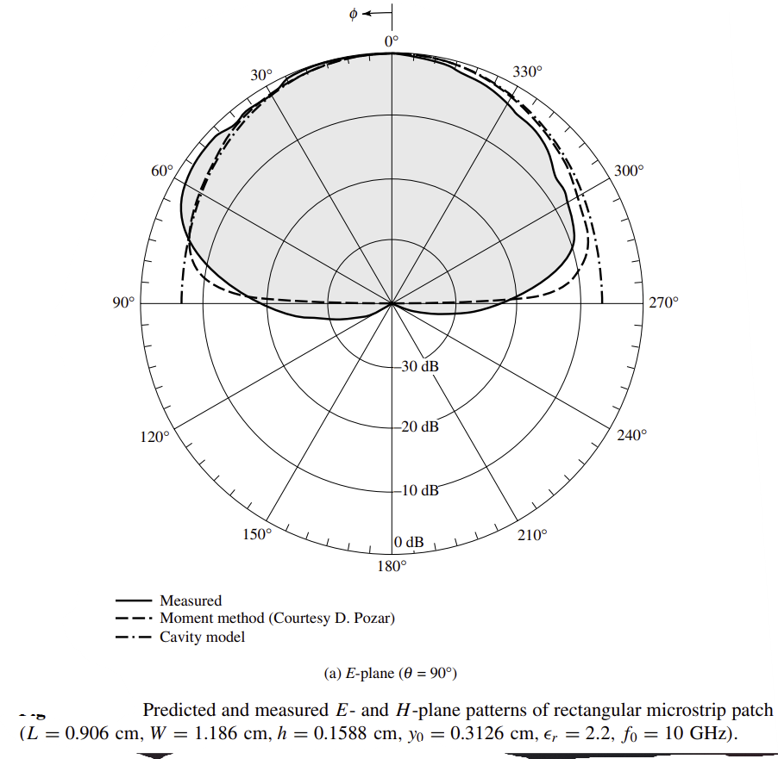

Microstrip patch antennas find **applications** across a wide range of fields due to their compact size, ease of fabrication, and versatility. Some common applications include:

1. **Wireless Communication Systems**: They are widely used in mobile phones, WLAN (Wi-Fi) devices, Bluetooth devices, RFID (Radio Frequency Identification) systems, and other wireless communication devices where compact size and efficient radiation are critical.
2. **Satellite Communication**: Microstrip patch antennas are employed in satellite communication systems for both transmission and reception of signals. Their directional radiation patterns and high gain make them suitable for long-distance communication links.
3. **Radar Systems**: They are used in radar systems for detection, tracking, and imaging applications. Their ability to provide directional radiation patterns and high efficiency at microwave frequencies makes them ideal for radar antenna arrays.
4. **Remote Sensing**: Microstrip patch antennas are used in remote sensing applications such as weather monitoring, environmental sensing, and Earth observation satellites due to their ability to operate effectively in satellite platforms.
5. **GPS (Global Positioning System)**: They are used in GPS receivers and navigation systems to receive signals from GPS satellites. Their compact size and directional properties help in accurately determining position and timing.

These applications highlight the versatility and importance of microstrip patch antennas in modern communication, navigation, sensing, and connectivity systems across various industries.

**Creating an omnidirectional antenna using microstrip patch technology** involves designing the antenna to radiate equally in all directions around its axis. Here are the general steps to create such an antenna:

1. **Select Design Parameters**:
   * Determine the operating frequency range and bandwidth requirements for your omnidirectional antenna.
   * Choose a suitable dielectric substrate material with a desired relative permittivity (dielectric constant) and thickness.
2. **Patch Geometry Design**:
   * Design a circular or annular microstrip patch. A circular patch is commonly used for omnidirectional radiation.
   * Calculate the dimensions of the patch based on the desired resonant frequency and substrate properties using electromagnetic simulation software or design equations.
3. **Feed Mechanism**:
   * Decide on the feed mechanism. A coaxial probe feed or aperture coupling technique is typically used for microstrip patch antennas.
   * Position the feed point at the center of the circular patch for symmetrical radiation.
4. **Ground Plane Design**:
   * Design and layout the ground plane beneath the substrate. The ground plane should be large enough to support the patch and provide a good reflector for the electromagnetic waves.
5. **Simulation and Optimization**:
   * Use electromagnetic simulation software (such as HFSS, CST Microwave Studio, or others) to simulate the antenna design.
   * Optimize the dimensions and feed location to achieve desired omnidirectional radiation pattern, impedance matching, and bandwidth.
6. **Fabrication**:
   * Fabricate the antenna prototype using standard PCB manufacturing techniques.
   * Print the microstrip patch and ground plane on opposite sides of the dielectric substrate.
   * Ensure precise dimensions and alignment of the feed point.
7. **Testing and Tuning**:
   * Test the fabricated antenna prototype using network analyzers or antenna measurement equipment.
   * Measure the return loss (S11 parameter), radiation pattern, and gain characteristics.
   * Fine-tune the antenna dimensions or feed location if necessary to achieve desired performance.
8. **Integration and Deployment**:
   * Once the antenna design is verified and tuned, integrate it into your wireless communication system or device.
   * Consider environmental factors and integration requirements for deployment.

By following these steps, you can create an omnidirectional microstrip patch antenna suitable for various applications where uniform radiation in all directions is desired, such as in WLAN devices, RFID systems, and small satellite communication systems.

PARABOLIC REFLECTOR ANTENNA

A parabolic reflector antenna is a type of antenna that uses a parabolic reflector (a curved surface in the shape of a paraboloid) to focus radio waves onto a small feed antenna placed at the focal point.

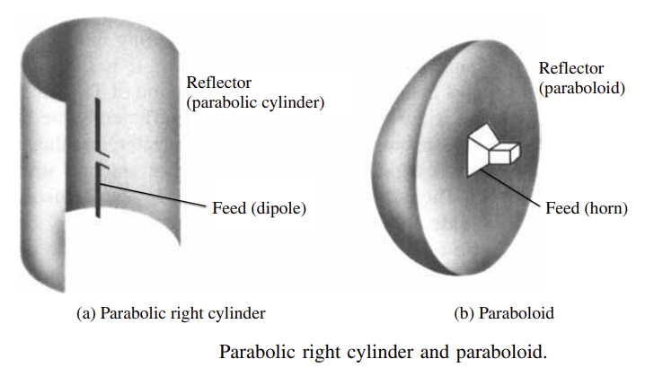

The structure of a parabolic reflector antenna consists of several key components designed to focus radio waves effectively:

1. **Parabolic Reflector**: The main component is the parabolic reflector itself, which is typically a dish-shaped surface curved in the shape of a paraboloid. This shape is crucial because it reflects incoming or outgoing radio waves towards or from a single focal point.
2. **Support Structure**: The reflector is usually mounted on a sturdy support structure, which could be a metal frame or a mast. This structure ensures the reflector maintains its shape and orientation.
3. **Feed Antenna**: At the focal point of the parabolic reflector, a small feed antenna is positioned. This feed antenna could be a dipole, a horn antenna, or another type suitable for the frequency and application of the antenna. It is placed precisely at the focal point to receive or transmit the focused radio waves.
4. **Feed Support Structure**: The feed antenna is often mounted on a support structure that positions it accurately at the focal point of the reflector. This structure ensures stability and precise alignment.
5. **Backing Structure**: Behind the reflector, there might be a backing structure or surface. This backing can help reinforce the reflector's shape and sometimes serves to protect the feed antenna from external elements.
6. **Mounting Mechanism**: Depending on the application, the entire antenna assembly may include a mounting mechanism to orient the reflector towards the desired direction for optimal signal reception or transmission.

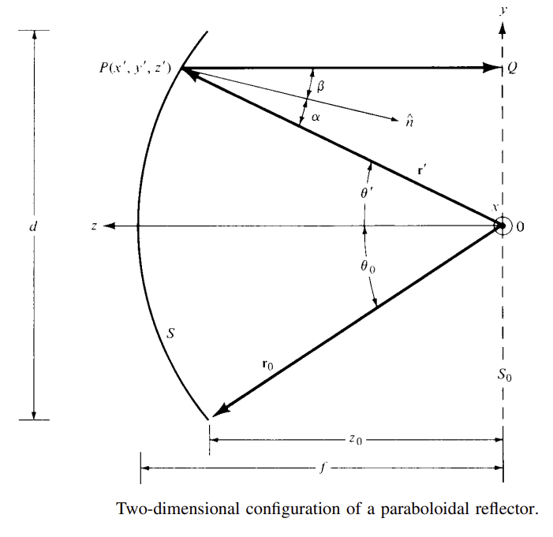Overall, the structure of a parabolic reflector antenna is designed to efficiently gather or transmit radio waves using the reflective properties of its parabolic shape, focusing them onto a small feed antenna positioned at the focal point. This design allows for high gain and directional characteristics, making it suitable for various communication and radar applications.

Parabolic reflector antennas possess several key **properties** that make them advantageous for various communication and radar applications:

1. **High Gain**: The parabolic shape of the reflector allows the antenna to achieve high gain. Gain refers to the ability of the antenna to focus radio waves in a specific direction, effectively increasing signal strength in that direction. This makes parabolic antennas ideal for long-distance communication where signal strength needs to be maximized.
2. **Directionality**: Parabolic reflector antennas are highly directional. They concentrate radio waves onto a small feed antenna located at the focal point of the reflector. This directional focusing enhances both the transmission of signals and the reception of weak signals from specific directions, while minimizing interference from other directions.
3. **Narrow Beamwidth**: The beamwidth of a parabolic reflector antenna is relatively narrow. Beamwidth refers to the angular width of the main lobe (the central region of maximum radiation intensity) of the antenna's radiation pattern. A narrower beamwidth means the antenna can focus its energy more precisely in the desired direction, improving communication link quality and reducing interference.
4. **Frequency Versatility**: Parabolic reflector antennas can be designed to operate across a wide range of frequencies, from relatively low frequencies used in terrestrial communication to higher frequencies used in satellite communication and radar systems. This versatility makes them suitable for various applications across different frequency bands.
5. **Large Aperture**: The size of the parabolic reflector determines its aperture, which is the effective area that captures or emits radio waves. Larger apertures provide higher gain and better performance, especially at higher frequencies where smaller antennas may not suffice.
6. **Efficiency**: Parabolic reflector antennas are known for their high efficiency in converting electrical signals to radio waves (for transmission) or vice versa (for reception). The parabolic shape minimizes energy losses and optimizes the transfer of energy to/from the feed antenna.
7. **Weather Resistance**: Depending on their construction materials and design, parabolic reflector antennas can be weather-resistant and suitable for outdoor use. They can withstand environmental factors such as wind, rain, and temperature variations, making them reliable for continuous operation in various conditions.

Overall, the properties of parabolic reflector antennas make them essential for applications requiring high gain, directional focusing, and efficient transmission or reception of radio waves over long distances. Their design and performance characteristics contribute to their widespread use in satellite communication, radar systems, microwave links, and other critical communication technologies.

Parabolic reflector antennas find numerous **applications** across different fields due to their ability to focus radio waves efficiently. Here are some common applications:

1. **Satellite Communication**: Parabolic reflector antennas are extensively used for both satellite ground stations and satellite communication terminals on spacecraft. They facilitate the transmission and reception of signals to and from satellites in geostationary or other orbits.
2. **Radar Systems**: In radar applications, parabolic reflector antennas are used to transmit and receive radar signals. They are employed in various radar systems such as weather radar, air traffic control radar, and military radar systems for detecting and tracking objects.
3. **Microwave Links**: Parabolic antennas are used in microwave point-to-point communication links, particularly in telecommunications networks. They provide high gain and directional beam characteristics, enabling long-distance transmission of microwave signals between locations.
4. **Broadcasting**: They are used in broadcasting applications for transmitting television and radio signals over long distances. Large parabolic antennas are often seen at broadcasting stations and relay stations for signal distribution.
5. **Wireless Internet**: Parabolic antennas are utilized in wireless internet service provider (WISP) networks and in rural broadband deployments. They help establish long-range connections between base stations and subscriber units, improving coverage and bandwidth.
6. **Radio Astronomy**: Parabolic reflector antennas are fundamental tools in radio astronomy observatories. They are used to collect radio waves from celestial objects and phenomena, enabling astronomers to study the universe at radio frequencies.
7. **Remote Sensing**: In remote sensing applications, such as Earth observation satellites and environmental monitoring systems, parabolic antennas are used to transmit and receive data from remote sensors, providing critical information for scientific research and monitoring purposes.
8. **Military and Defense**: Parabolic antennas play a crucial role in military communications, surveillance, and electronic warfare systems. They are used for secure communication links, radar surveillance, and intelligence gathering operations.
9. **Navigation Systems**: In global navigation satellite systems (GNSS) like GPS, parabolic antennas are used in ground-based receivers to receive signals from satellite constellations and calculate accurate positioning information.
10. **Scientific Research**: They are also used in various scientific experiments and research projects requiring precise control and measurement of electromagnetic signals, such as in particle accelerators and laboratory experiments.

These applications highlight the versatility and importance of parabolic reflector antennas in modern communications, scientific research, and defense technologies where high gain, directional control, and efficient signal transmission are critical requirements.

**Creating an omni-directional antenna using a parabolic reflector** involves modifying the reflector to achieve a broader radiation pattern rather than focusing the signal in a single direction. Here are the steps to create such an antenna:

1. **Select a Parabolic Reflector**: Choose a parabolic reflector with a diameter appropriate for your desired frequency range and application. Larger reflectors typically provide better omni-directional performance at lower frequencies.
2. **Modify the Feed Antenna**: Instead of placing a single feed antenna (which would focus the signal in a specific direction), modify the feed system to radiate or receive signals in a more omni-directional pattern. Here are a few methods:
   * **Multiple Feed Elements**: Install multiple feed elements around the focal point of the parabolic reflector. These can be dipole antennas, small horns, or other types of radiators arranged symmetrically. Each feed element should be fed with equal amplitude and phase to achieve a broad radiation pattern.
   * **Feed Array**: Use a feed array consisting of several closely spaced antennas arranged in a circular or other symmetric pattern. The spacing and phase relationships between the antennas in the array will determine the resulting radiation pattern.
   * **Feed Horn with Reflector**: Install a feed horn antenna designed to radiate or receive signals in an omni-directional pattern. The horn should be positioned at the focal point and designed to emit or capture signals with a broader beamwidth.
3. **Adjust Feed Position**: Position the feed elements or feed horn at the focal point of the parabolic reflector. The distance and alignment are critical to ensure the best performance of the omni-directional pattern.
4. **Testing and Adjustment**: After assembling the antenna, test its performance using suitable equipment. Adjust the feed elements' positions, amplitudes, and phases to achieve the desired omni-directional radiation pattern.
5. **Reflector Shape Optimization**: Depending on the specific requirements and design considerations, you may need to slightly modify the parabolic shape of the reflector to optimize the omni-directional performance. This step might involve adjustments in curvature or minor alterations to the reflector's surface.
6. **Mounting and Deployment**: Once the antenna has been optimized for omni-directional performance, securely mount it in its intended location. Ensure that the mounting structure provides stability and maintains the orientation of the reflector and feed system.
7. **Performance Evaluation**: Conduct thorough performance evaluations to ensure that the omni-directional antenna meets the desired specifications for gain, radiation pattern coverage, and efficiency across the desired frequency range.

By following these steps, you can modify a parabolic reflector antenna to achieve omni-directional characteristics suitable for applications where coverage in multiple directions is required.

YAGI-UDA ANTENNA

The Yagi-Uda antenna, often referred to simply as a Yagi antenna, is a directional antenna commonly used in radio communications, television broadcasting, and other applications requiring high gain and directivity. It consists of a driven element (active element), typically a dipole or folded dipole antenna, and several passive elements (parasitic elements) arranged in a specific geometric pattern.

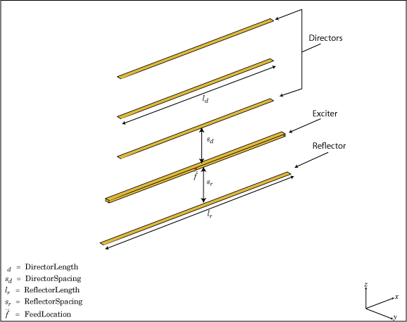

The Yagi-Uda antenna consists of several key **structural** elements that work together to achieve its directional characteristics and high gain. Here's a breakdown of its typical structure:

1. **Driven Element:**
   * The driven element is the active element of the antenna. It is usually a dipole or a folded dipole antenna. This element is connected directly to the feed line, which carries the RF signal to be transmitted or received.
2. **Parasitic Elements:**
   * These are additional metal rods or elements that are placed parallel to and alongside the driven element. They do not connect directly to the feed line but interact with the electromagnetic field generated by the driven element. The most common parasitic elements are:
     + **Director Elements:** These are shorter elements positioned in front of the driven element. They are typically a few percent shorter than the driven element. Directors help to focus the radiation pattern of the antenna in the forward direction, thereby increasing the gain of the antenna.
     + **Reflector Element:** This is a longer element positioned behind the driven element. It is typically 5% to 10% longer than the driven element. The reflector element reflects radiation forward and enhances the directivity of the antenna by creating constructive interference with the radiation from the driven element.
3. **Boom:**
   * The elements of the Yagi-Uda antenna are mounted on a supporting structure called the boom. The boom is usually a metallic or non-metallic rod or tube that runs parallel to the elements and provides mechanical support and spacing between them.
4. **Feed Line:**
   * The feed line is the cable that connects the driven element to the transmitter or receiver. It carries the RF signal to or from the antenna.
5. **Matching Network (Optional):**
   * In some designs, a matching network may be used to match the impedance of the feed line to the impedance of the driven element, ensuring efficient transfer of RF energy.

The specific dimensions and spacing between elements are critical in determining the operating frequency and characteristics of the Yagi-Uda antenna. By carefully designing the lengths and positions of the parasitic elements relative to the driven element, engineers can control the antenna's radiation pattern, gain, and directivity.

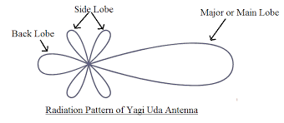

The Yagi-Uda antenna, commonly known as a Yagi antenna, is a type of directional antenna widely used in radio communication and broadcasting due to its high gain and directional **properties**. Here's a detailed explanation of its structure:

1. **Driven Element:**
   * The heart of the Yagi-Uda antenna is the driven element, which is usually a dipole antenna. This element is directly connected to the feed line (coaxial cable or other transmission line) that carries the RF signal to or from the antenna.
2. **Parasitic Elements:**
   * Surrounding the driven element are one or more parasitic elements. These elements do not connect directly to the feed line but interact electromagnetically with the driven element to achieve directional characteristics. The parasitic elements typically include:
     + **Director Elements:** These are shorter elements positioned in front of the driven element. Directors are typically 5% to 10% shorter than the driven element. They focus the radiation pattern of the antenna in the forward direction, increasing the antenna's gain and directivity.
     + **Reflector Element:** Positioned behind the driven element, the reflector is usually slightly longer (about 5% to 10%) than the driven element. It reflects and concentrates the radiation forward, enhancing the antenna's directivity and efficiency.
3. **Boom:**
   * All elements (driven and parasitic) are mounted on a support structure called the boom. The boom is typically a metal or non-metallic rod or tube that runs parallel to the elements. It provides mechanical support and precise spacing between the elements, which is crucial for the antenna's performance.
4. **Spacing and Dimensions:**
   * The spacing and dimensions of the elements (driven and parasitic) are critical and determined based on the operating frequency of the antenna. These dimensions are calculated to optimize the antenna's radiation pattern, gain, and impedance matching.
5. **Feed Line:**
   * The feed line connects to the driven element and carries the RF signal to or from the antenna. It is crucial for efficient transmission or reception of electromagnetic waves.
6. **Matching Network (Optional):**
   * In some designs, a matching network may be used to adjust the impedance of the feed line to match the impedance of the driven element. This ensures maximum power transfer and efficiency.

Overall, the Yagi-Uda antenna achieves its high gain and directionality by carefully arranging the driven and parasitic elements on a boom, with precise dimensions and spacings. This construction allows it to focus its radiation pattern in a specific direction, making it ideal for point-to-point communication and applications where directional antennas are advantageous.

Yagi-Uda antennas find **applications** in various fields where directional communication with high gain is essential. Some common applications include:

1. **Television Reception:**
   * Yagi antennas are widely used for television reception in areas where signals are weak or spread over a wide area. Their directional properties help in aiming at television broadcast towers to improve signal reception.
2. **Radio Communication:**
   * They are extensively used in amateur radio (HAM radio) operations for both transmitting and receiving signals over long distances. Their high gain and directional characteristics make them suitable for point-to-point communication.
3. **Wireless Networking:**
   * Yagi antennas are used in wireless networking applications (Wi-Fi) to establish long-range connections between two points. They are often employed in point-to-point links for internet service providers (ISPs) and in outdoor wireless networks.
4. **Radar Systems:**
   * Yagi-Uda antennas are used in radar systems for both military and civilian applications. They can be used as transmitting antennas to emit radar pulses or as receiving antennas to detect reflected radar signals.
5. **Remote Sensing:**
   * In remote sensing applications, such as weather radar and satellite ground stations, Yagi antennas are used to receive signals from satellites or other remote sensing platforms.

**Creating an omnidirectional antenna using a Yagi-Uda design** is somewhat counterintuitive since Yagi antennas are inherently directional. However, there are methods to approximate omnidirectional characteristics by modifying the Yagi design. Here are steps you can consider:

1. **Design the Driven Element:**
   * Start with a standard Yagi-Uda driven element, which is typically a dipole or folded dipole antenna. This will be the element that directly connects to your feed line (coaxial cable).
2. **Modify Parasitic Elements:**
   * Instead of using director and reflector elements that focus radiation in a single direction, you can create multiple elements around the driven element. Arrange these elements symmetrically around the driven element to distribute radiation more evenly in all directions.
   * For example, you might add shorter elements (like stubs or additional dipoles) around the driven element to create a more uniform radiation pattern.
3. **Adjust Element Lengths and Spacings:**
   * Modify the lengths and spacings of the parasitic elements based on the desired operating frequency. While maintaining symmetry, adjust the lengths to achieve a balance between gain and omnidirectionality.
4. **Use a Balun (Balanced-Unbalanced Transformer):**
   * Employ a balun to match the balanced impedance of the Yagi-Uda antenna to the unbalanced impedance of the coaxial feed line. This ensures efficient transfer of RF energy and minimizes signal loss.
5. **Testing and Optimization:**
   * Once constructed, test the antenna using an SWR (Standing Wave Ratio) meter or antenna analyzer to ensure it performs as expected across the desired frequency range.
   * Adjust element lengths and spacings as necessary to optimize performance for omnidirectional characteristics while maintaining acceptable gain.
6. **Consider Ground Plane:**
   * Depending on the design, you may need to include a ground plane to enhance the antenna's performance, especially for omnidirectional radiation patterns.
7. **Iterate and Fine-tune:**
   * Antenna design often involves iterative adjustments. Fine-tune the design based on real-world testing and feedback to achieve the desired omnidirectional performance while maintaining reasonable gain.

Creating a truly omnidirectional antenna from a Yagi-Uda design involves balancing compromises in gain and directivity. It's important to note that while these steps can approximate omnidirectional characteristics, true omnidirectionality is best achieved with antennas specifically designed for that purpose, such as collinear arrays or vertically polarized omnidirectional antennas.

MATLAB Codes and Results

1.a) Observing Characteristics of Dipole Antenna Element:

clc;

clearvars;

freq=2.44e9;

antenna=design(dipole,freq);

figure;

show(antenna);

figure;

pattern(antenna,freq);

title("Radiation Pattern");

figure;

pattern(antenna,freq,0,0:1:360);

title("Gain");

figure;

pattern(antenna,freq,0:1:360,0);

title("Directivity");

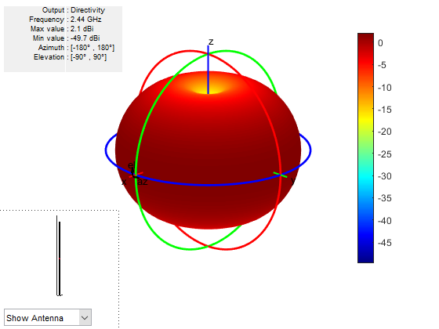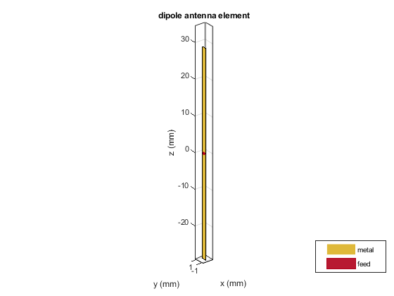

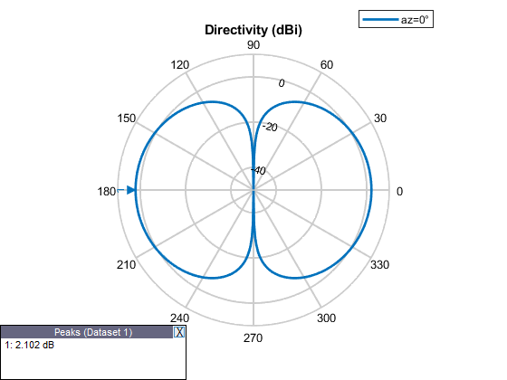

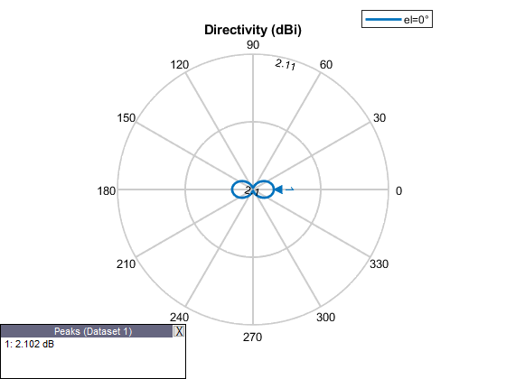

1.b) Designing Omnidirectional Antenna using Dipole Antenna:

clearvars;

numElements=8;

radius=0.5;

Tilt=rad2deg(0);

freq=2.44e9;

antenna=design(dipole,freq);

antenna.Tilt=90;

antenna.TiltAxis='Y';

Theta=linspace(0,2*pi,numElements+1);

Theta(end)=[];

x=radius*cos(Theta);

y=radius*sin(Theta);

z=zeros(1,numElements);

Positions=[x;y;z;]';

tiltedAntennaTemplate=copy(antenna);

tiltedAntennaTemplate.Tilt=rad2deg(Tilt);

tiltedAntennas= repmat({tiltedAntennaTemplate},1,numElements);

circularArray= conformalArray('Element',tiltedAntennas,'ElementPosition',Positions);

figure;

show(circularArray);

title("Omnidirectional Antenna using Dipole Antennae");

figure;

pattern(circularArray,freq);

title("Radiation Pattern");

figure;

pattern(circularArray,freq,0,0:1:360);

title("Gain");

figure;

pattern(circularArray,freq,0:1:360,0);

title("Directivity");

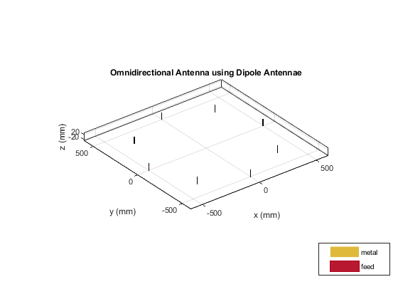

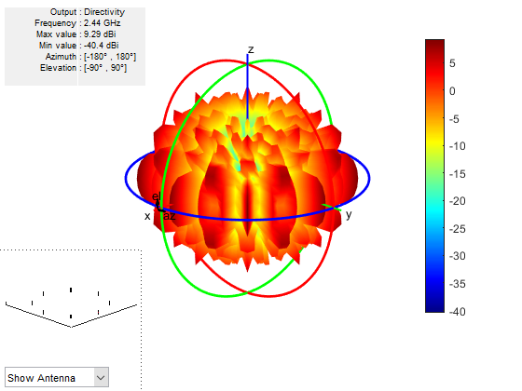

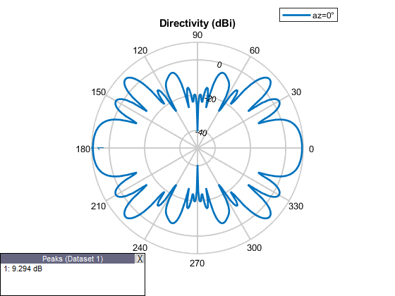

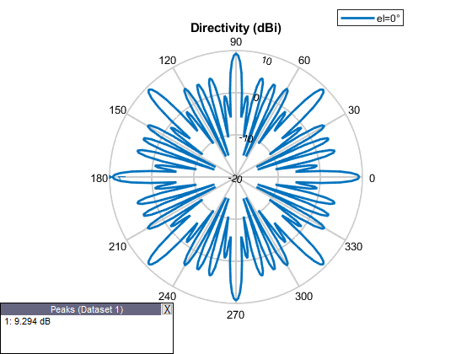

2.a) Observing Characteristics of Horn Antenna Element:

clc;

clearvars;

freq=2.44e9;

h=horn('FlareLength',0.634,'FlareWidth',0.532,'FlareHeight',0.355,'Length',0.104,'Width',0.0921,'Height',0.0461,'FeedHeight',0.0269);

antenna=design(h,freq);

figure;

show(antenna);

figure;

pattern(antenna,freq);

title("Radiation Pattern");

figure;

pattern(antenna,freq,0,0:1:360);

title("Gain");

figure;

pattern(antenna,freq,0:1:360,0);

title("Directivity");

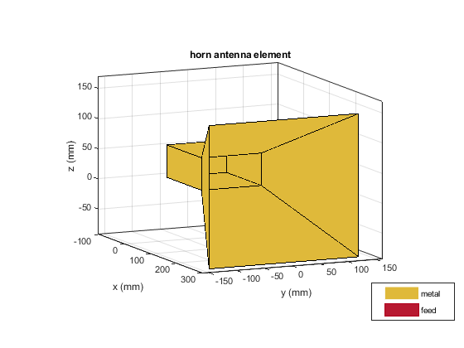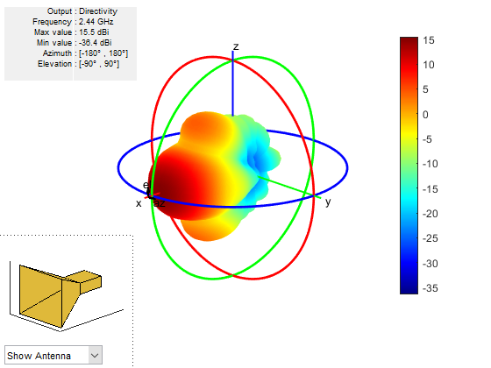

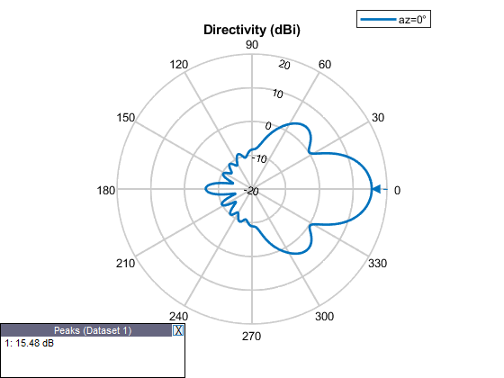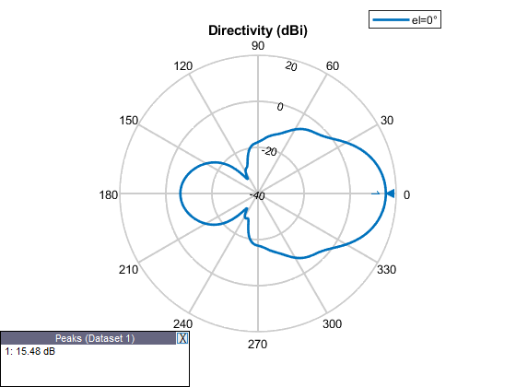

2.b) Designing Omnidirectional Antenna using Horn Antennae:

clc;

clearvars;

numElements=8;

radius=10;

freq=2.44e9;

h=horn('FlareLength',0.634,'FlareWidth',0.532,'FlareHeight',0.355,'Length',0.104,'width',0.0921,'Height',0.0461,'FeedHeight',0.0269);

antenna=design(h,freq);

Theta=linspace(0,2*pi,numElements+1);

Theta(end)=[];

x=radius*cos(Theta);

y=radius*sin(Theta);

z=zeros(1,numElements);

Positions=[x;y;z;]';

tiltedAntennas = cell(1,numElements);

for i = 1:numElements

   tiltedAntennas{i} = copy(antenna);

   tiltedAntennas{i}.TiltAxis=[1 0 0;0 0 1];

   tiltedAntennas{i}.Tilt=[90 rad2deg(Theta(i)+(2*pi))];

end

 circularArray= conformalArray('Element',tiltedAntennas,'ElementPosition',Positions);

figure;

show(circularArray);

title("Omnidirectional Antenna using Horn Antennae");

 figure;

pattern(circularArray,freq);

title("Radiation Pattern");

 figure;

pattern(circularArray,freq,0,0:1:360);

title("Gain");

 figure;

pattern(circularArray,freq,0:1:360,0);

title("Directivity");

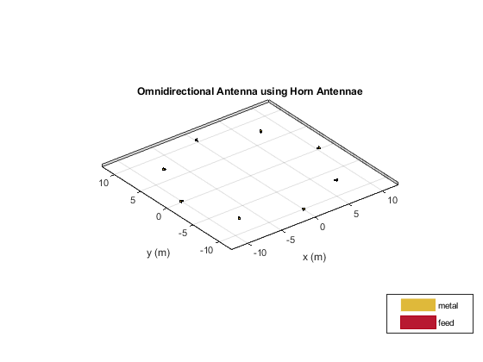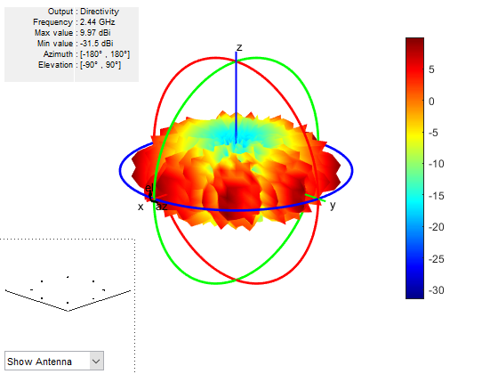

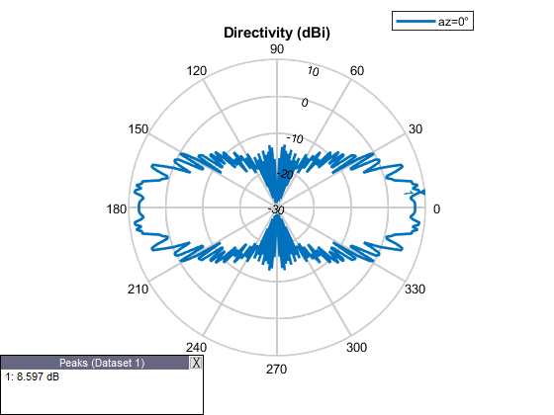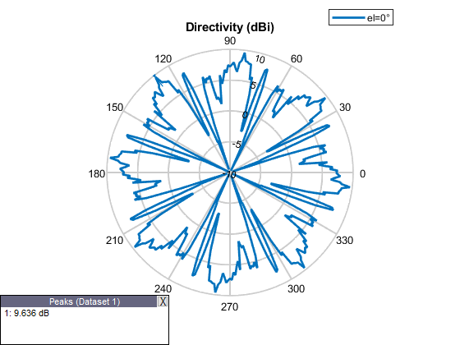

3.a) Observing Characteristics of Microstrip Patch Antenna Element:

clc;

clearvars;

freq=2.44e9;

d = dielectric('Air');

pm=patchMicrostrip('Substrate',d);

antenna=design(pm,freq);

figure;

show(antenna);

figure;

pattern(antenna,freq);

title("Radiation Pattern");

figure;

pattern(antenna,freq,0,0:1:360);

title("Gain");

figure;

pattern(antenna,freq,0:1:360,0);

title("Directivity");

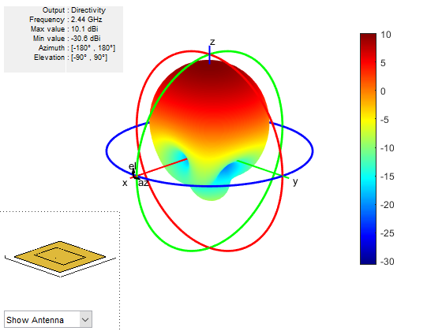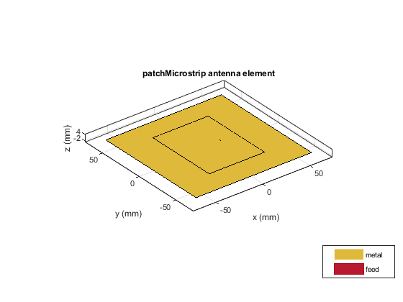

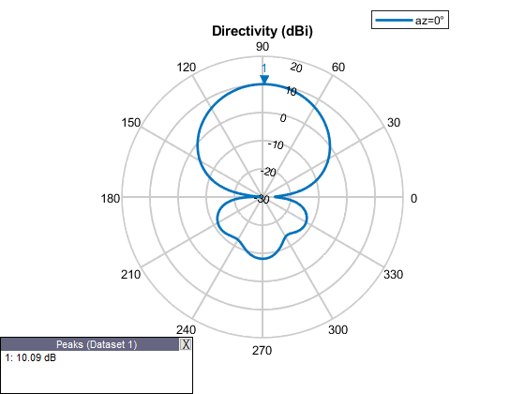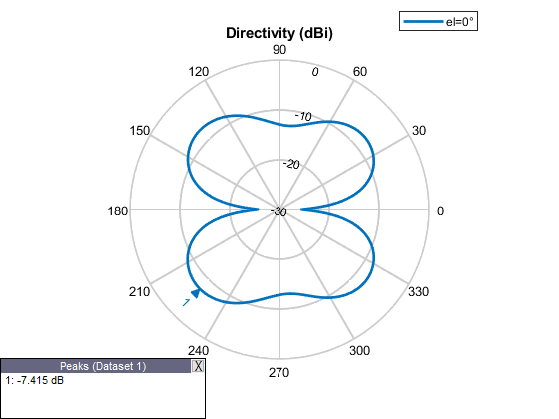

3.b) Designing Omnidirectional Antenna using Microstrip Patch Antennae:

clc;

clearvars;

numElements=8;

radius=10;

freq=2.44e9;

d = dielectric(‘Air’);

pm=patchMicrostrip('Substrate',d);

antenna=design(pm,freq);

Theta=linspace(0,2*pi,numElements+1);

Theta(end)=[];

x=radius*cos(Theta);

y=radius*sin(Theta);

z=zeros(1,numElements);

Positions=[x;y;z;]';

tiltedAntennas = cell(1,numElements);

for i = 1:numElements

   tiltedAntennas{i} = copy(antenna);

   tiltedAntennas{i}.TiltAxis=[1 0 0;0 0 1];

   tiltedAntennas{i}.Tilt=[90 rad2deg(Theta(i)+(pi/2))];

end

 circularArray= conformalArray('Element',tiltedAntennas,'ElementPosition',Positions);

 figure;

show(circularArray);

title("Omnidirectional Antenna using Microstrip Patch Antennae");

 figure;

pattern(circularArray,freq);

title("Radiation Pattern");

 figure;

pattern(circularArray,freq,0,0:1:360);

title("Gain");

 figure;

pattern (circularArray, freq,0:1:360,0);

title("Directivity");

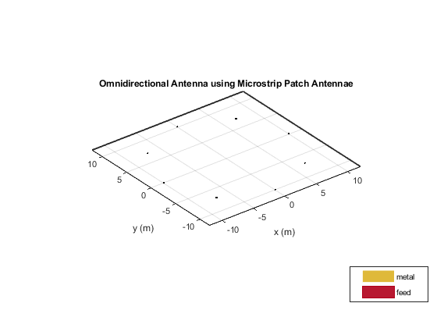

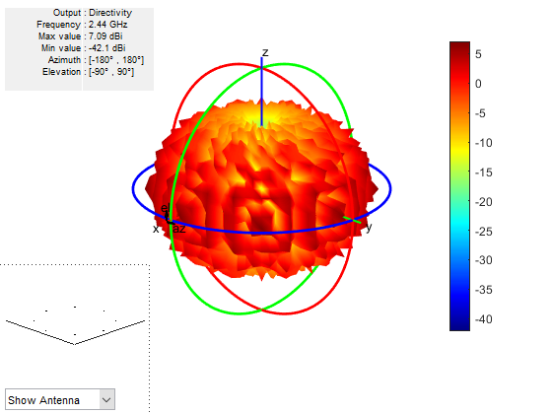

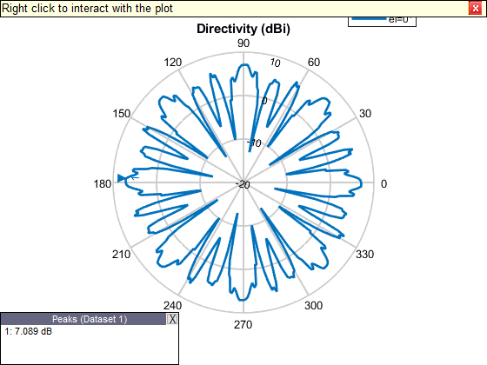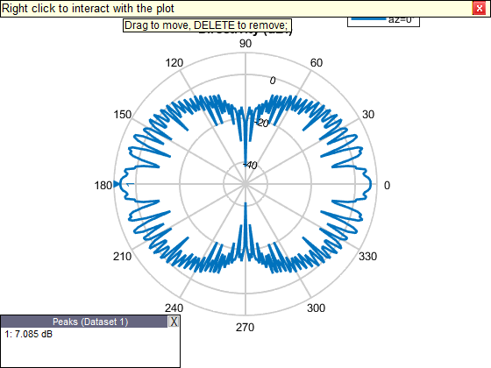

4.a) Observing Characteristics of Parabolic Reflector Antenna Element:

clear all;

close all;

freq = 2.4e9;

ParabolicAntenna = reflectorParabolic('Radius',2.50,'focalLength',1.25);

figure;

show(ParabolicAntenna);

title('omnidirectional antenna ');

figure;

pattern(ParabolicAntenna,freq);

title('omnidirectional antenna ');

figure;

pattern(ParabolicAntenna,freq,0,0:1:360);

title('omnidirectional antenna');

figure;

pattern(ParabolicAntenna,freq,0:1:360,0);

title('omnidirectional antenna');

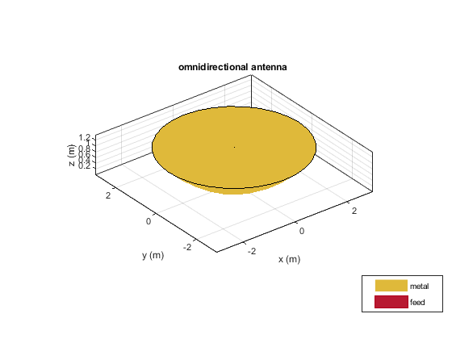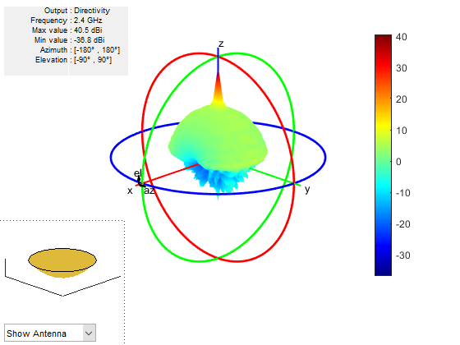

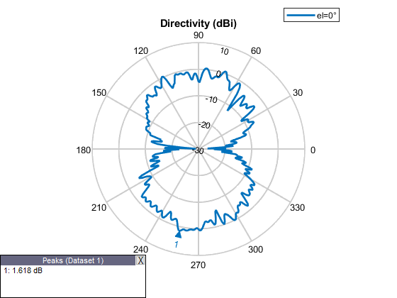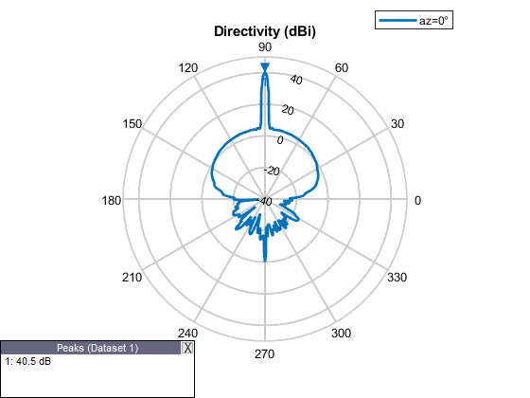

4.b) Designing Omnidirectional Antenna using Parabolic Reflector Antennae:

clc;

clearvars;

numElements=6;

radius = 6 ;

tiltAngle = rad2deg(0);

freq=2.44e9;

y1=2.5;

y2=y1/2;

antennaObject=design(reflectorParabolic,freq);

antennaObject.Radius=y1;

antennaObject.FocalLength=y2;

antennaObject.Tilt=0;

antennaObject.TiltAxis='X';

antennaObject.Exciter.Tilt=90;

antennaObject.Exciter.TiltAxis='Y';

Theta = linspace(0,2*pi,numElements+1);

Theta(end) = [ ];

x = radius*cos(Theta);

y = radius*sin(Theta);

z = zeros(1,6);

Positions = [x;y;z;]';

tiltedAntennas = cell(1,numElements);

for i = 1:numElements

   tiltedAntennas{i} = copy(antennaObject);

   tiltedAntennas{i}.Tilt = rad2deg(tiltAngle);

end

circularArray = conformalArray('Element',antennaObject,'ElementPosition',Positions);

figure;

pattern(circularArray,freq,0:1:360,0);

title('omnidirectional antenna');

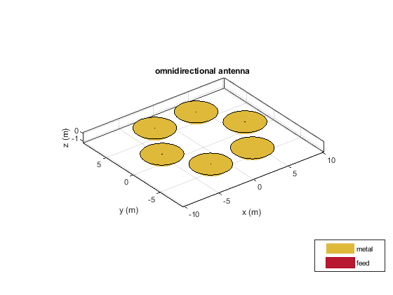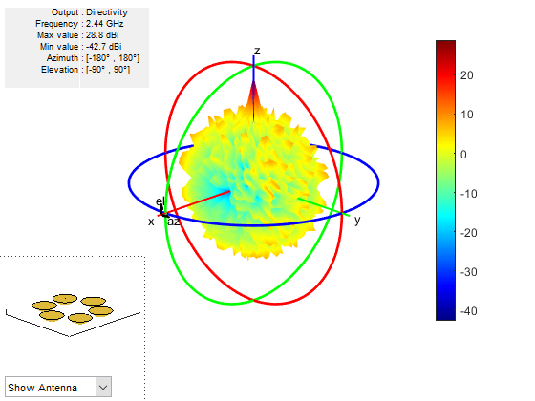

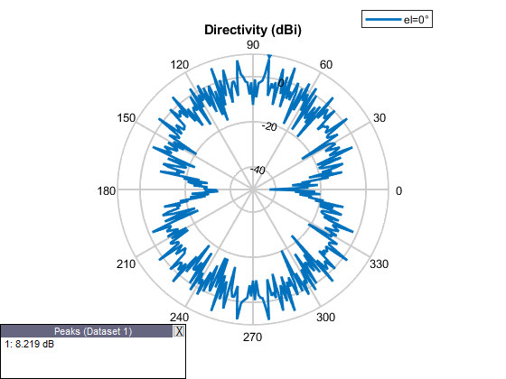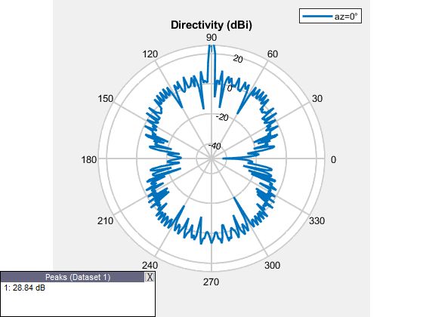

5.a) Observing Characteristics of Yagi-Uda Antenna Element:

clc;

clearvars;

freq=2.44e9;

yogi=yagiUda('numDirectors',15);

yagi=design(yogi,freq);

figure;

show(yagi);

figure;

pattern(yagi,freq);

title("Radiation Pattern");

figure;

pattern(yagi,freq,0,0:1:360);

title("Gain");

figure;

pattern(yagi,freq,0:1:360,0);

title("Directivity");

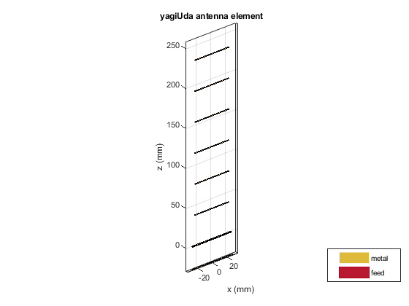

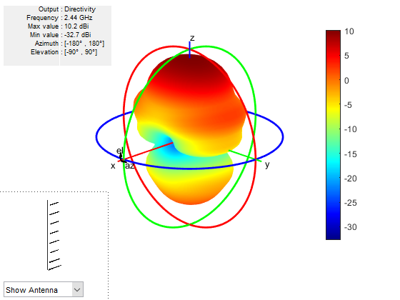

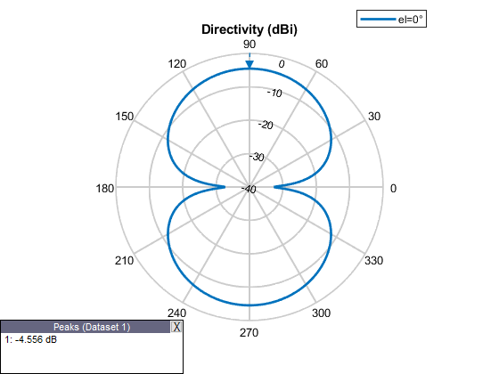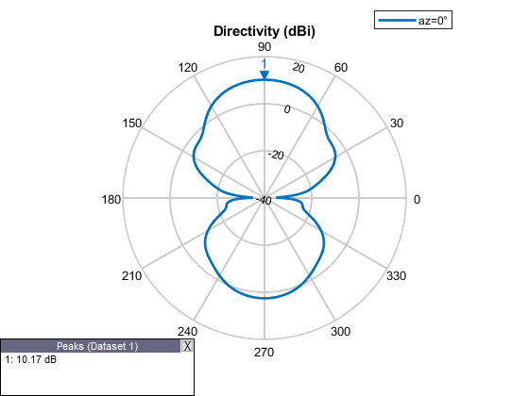

5.b) Designing Omnidirectional Antenna using Yagi-Uda Antennae:

numElements=8;

radius=5;

TiltAngle=rad2deg(0);

freq=2.44e9;

yogi=yagiUda('numDirectors',20);

yagi=design(yogi,freq);

yagi.Tilt=90;

yagi.TiltAxis='Y';

Theta=linspace(0,2*pi,numElements+1);

Theta(end)=[];

x=radius*cos(Theta);

y=radius*sin(Theta);

z=zeros(1,numElements);

Positions=[x;y;z;]';

tiltedAntennas = cell(1,numElements);

for i = 1:numElements

   tiltedAntennas{i} = copy(yagi);

   tiltedAntennas{i}.Tilt = rad2deg(TiltAngle);

end

circularArray= conformalArray('Element',tiltedAntennas,'ElementPosition',Positions);

figure;

show(circularArray);

title("Omnidirectional Antenna using Yagi-Uda Antennae");

figure;

pattern(circularArray,freq);

title("Radiation Pattern");

figure;

pattern(circularArray,freq,0,0:1:360);

title("Gain");

figure;

pattern(circularArray,freq,0:1:360,0);

title("Directivity");

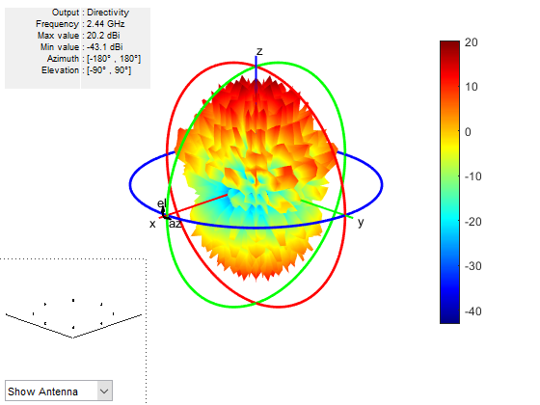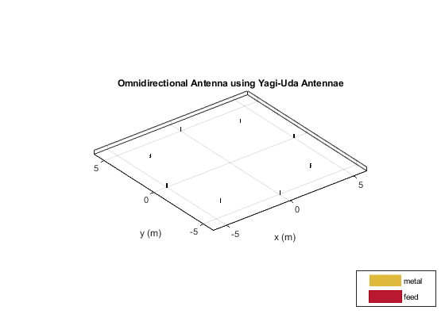  
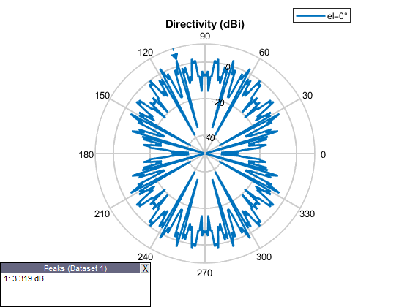

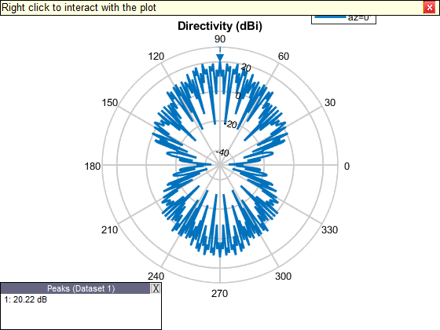

CONCLUSION

In this report on antennas, we explored the fundamental aspects, types, and creation of omni-directional antennas using MATLAB. Antennas are crucial components in communication systems, facilitating the transmission and reception of electromagnetic waves. The introduction provided a foundational understanding of antennas, highlighting their importance and basic working principles.

We then delved into various types of antennas, such as dipole, monopole, patch, and loop antennas. Each type has distinct characteristics and applications, ranging from simple designs for basic communication needs to complex structures for specialized purposes. Understanding these different types allows for better selection and implementation based on specific requirements.

The practical application of this knowledge was demonstrated through the creation of omni-directional antennas using MATLAB. By combining different types of antennas, we can achieve the desired omni-directional radiation pattern. MATLAB's robust simulation and design tools enable precise modeling and analysis, ensuring that the designed antennas meet the necessary performance criteria.

In conclusion, antennas play a pivotal role in modern communication systems, and understanding their types and design principles is essential for optimizing their performance. The use of MATLAB provides a powerful platform for designing and simulating antennas, allowing engineers to create efficient and effective omni-directional antennas tailored to specific needs. This report underscores the importance of antennas and the advantages of using advanced software tools for their development.

REFERENCES

* Antenna theory analysis and design (3rd Edition)  
   By. Constantine A. Balanis.
* John D. Kraus, Antennas, 3rd Edition, McGraw Hill, 2001
* <https://nptel.ac.in/courses/108/105/108105114/>
* <https://nptel.ac.in/courses/108/101/108101092/>
* <https://nptel.ac.in/courses/117/107/117107035/>